PWS1-135M Series
Bi-directional Storage Inverter

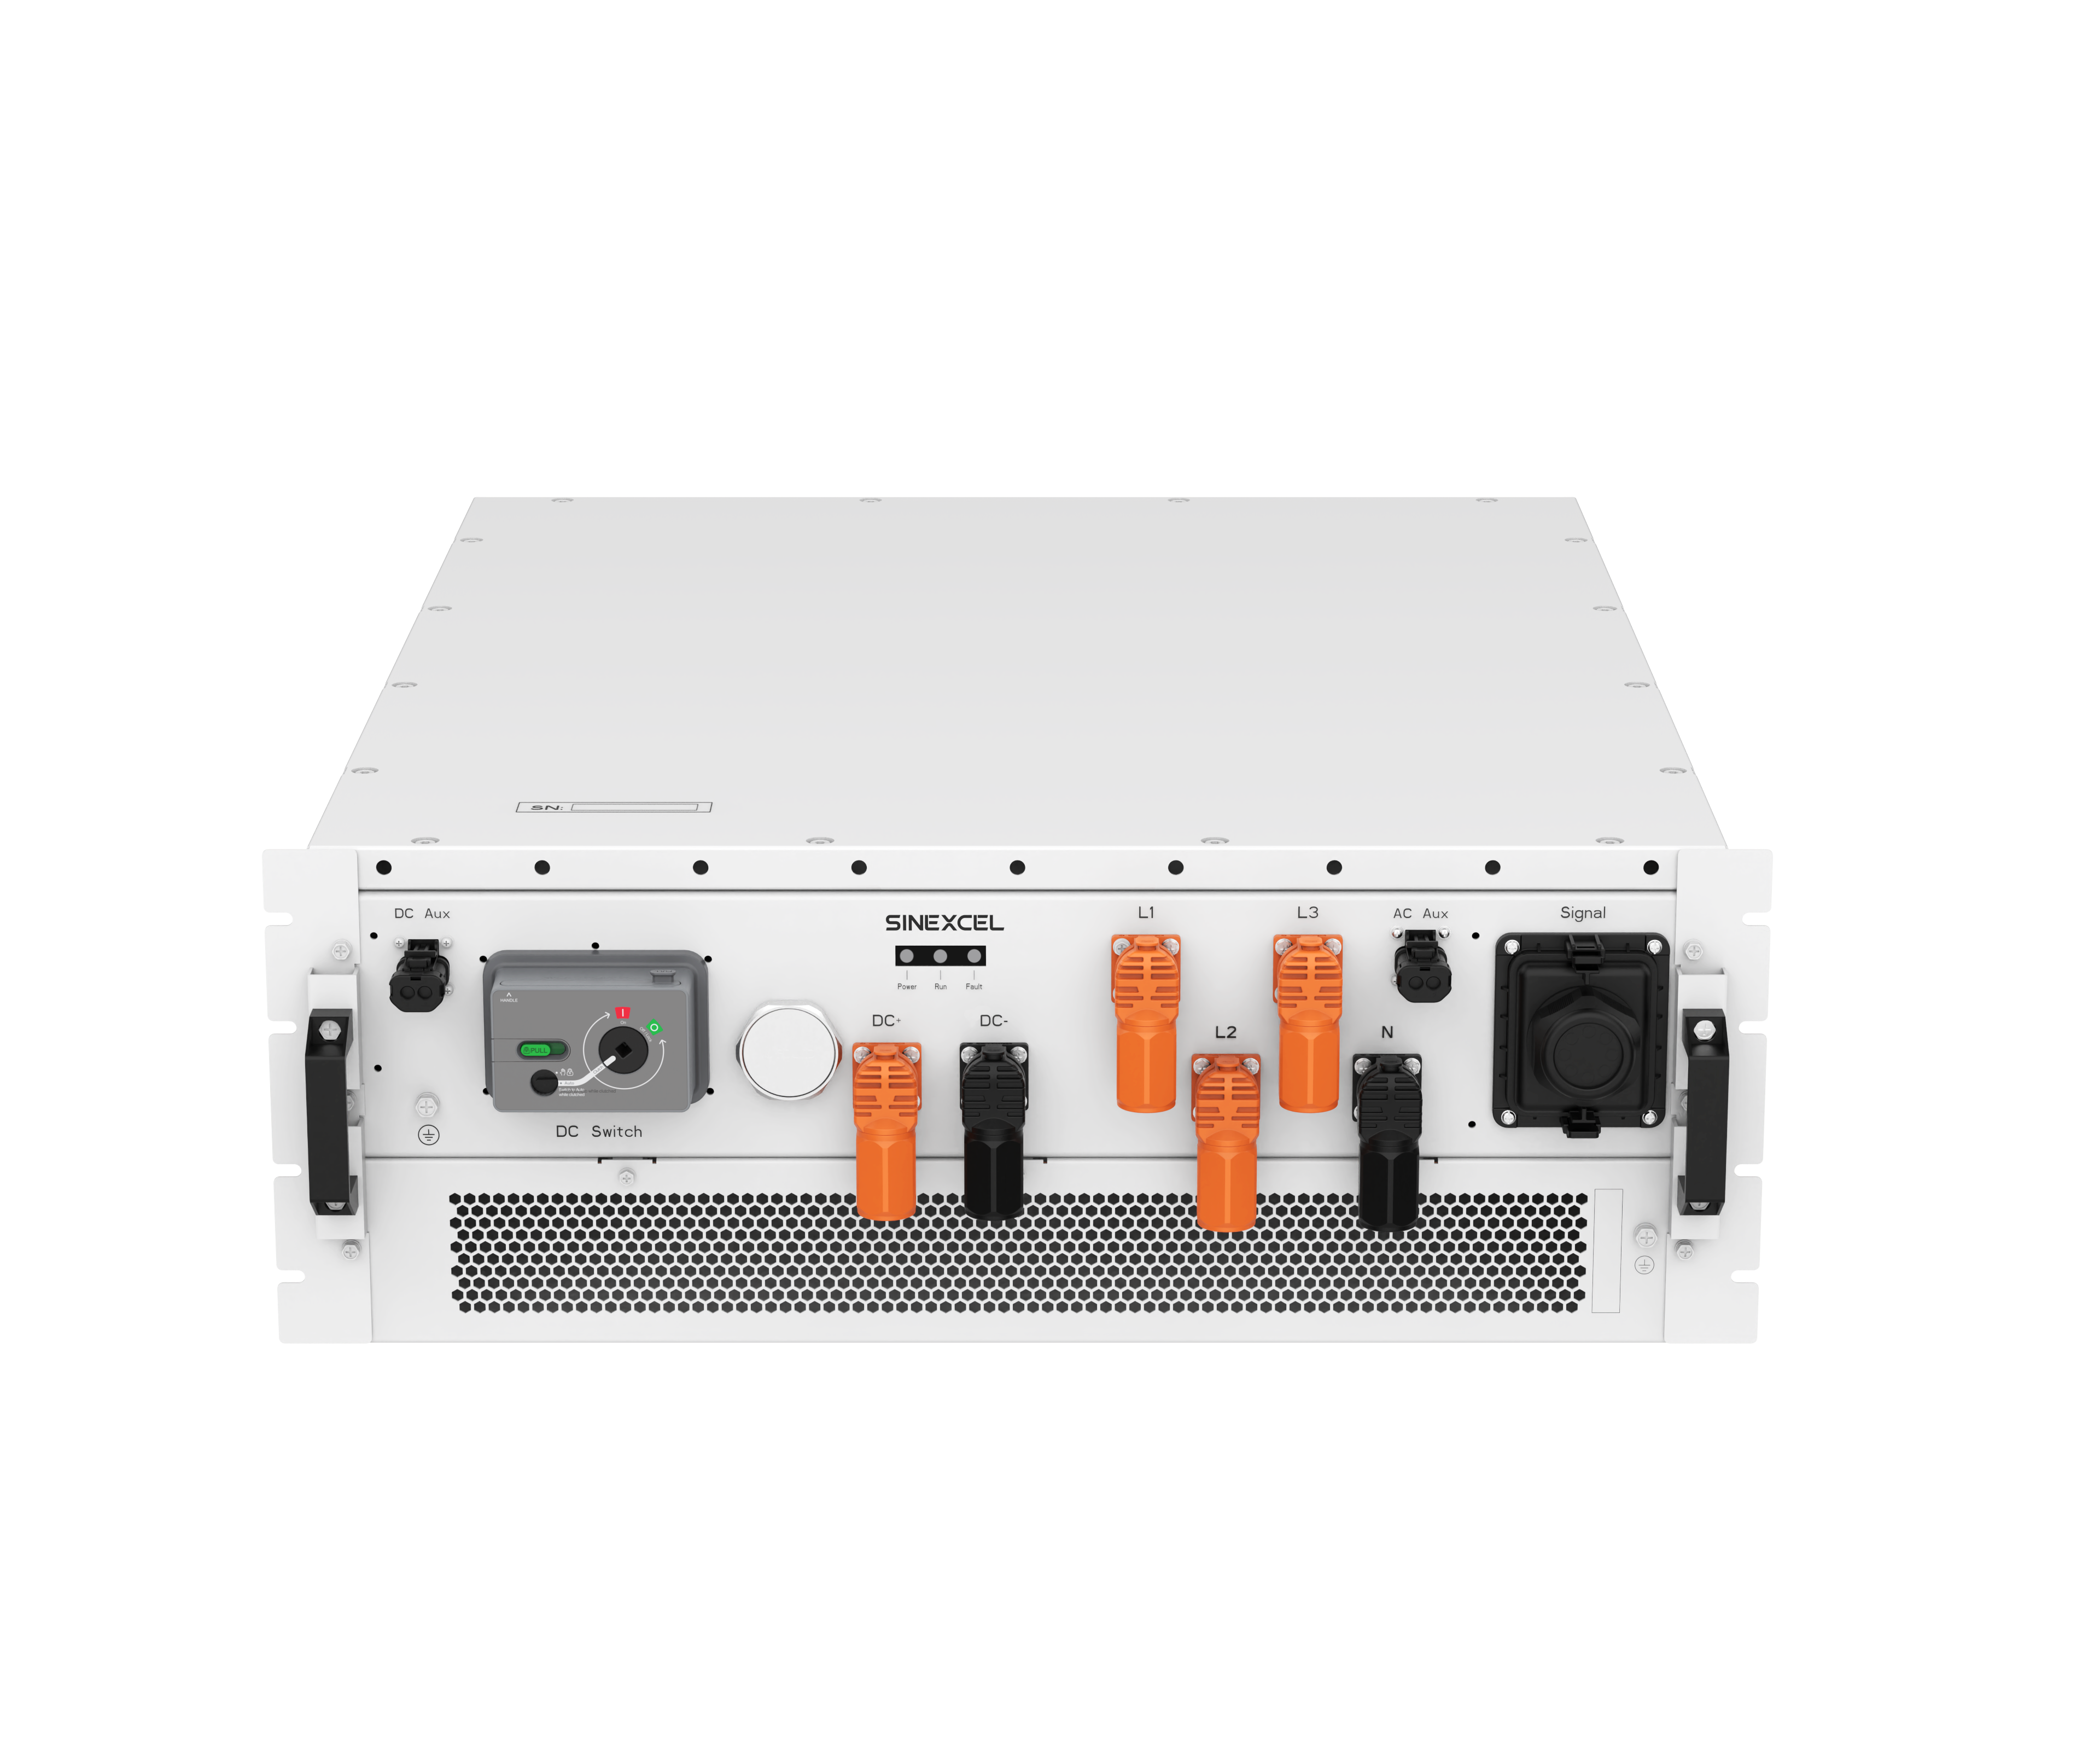

User
manual



Sinexcel
PWS1-135M Series Bi-directional Storage Inverter
User Manual
Version : A00-04

Shenzhen Sinexcel Electric Co.
All rights reserved. In case of any content change, it should be without prior notice.
No part of this document may be reproduced or transmitted in any form or by any means without prior written consent of Shenzhen Sinexcel Electric Co.

Website: www.sinexcel.us
Address：Block 6, Block 2, Baiwangxin Hi-Tech Industrial Park, No.1002 Songbai Road, Nanshan District, Shenzhen, China
Postcode: 518055
Contact：0755-8651-1588
Fax: 0755-8651-3100
E-mail: service@sinexcel.com

Content
1 Overview 1
1.1 Applicable Models 1
1.2 Target User 2
1.3 Terminology 3
2 Safety Information 4
2.1 Warning Signs 4
2.2 Important Safety Instructions 4
2.3 Additional Information 5
3 Product Introduction 6
3.1 System Introduction 6
3.2 System Schematic Diagram 6
3.3 PCS Panel Interface Definition 7
4 Technical Specification and Working Status 12
4.1 Parameter 12
4.2 Working Status 16
4.3 Operating State Switching 18
4.4 Operating Mode Introduction 18
4.5 Main Functions 18
5 Storage, Handling and Transportation 19
5.1 Transportation and Storage 19
5.2 Unpacking Inspection 20
5.3 Precautions for Handling 20
6 Equipment Installation 21
6.1 Installation Process 21
6.2 Installation Notes 21
6.3 Preparation for Installation 23
6.4 Installation Requirements 24
6.4.1 Environmental Requirements 24
6.4.2 Carrier Requirements 24
6.4.3 Ventilation Requirements 24
6.5 Electrical Installation and Connection 25
6.5.1 Electrical Connection 25
6.5.2 Communication Interface Connection 43
6.6 Installation Checklist 45
7 Operation and Debugging 47
7.1 Control Method 47
7.1.1 Ethernet Connection 47
7.1.2 RS485 Connection 48
7.2 Power-on and Power-off 48
7.2.1 Check before Starting 48
7.2.2 Power-on Steps 49
7.2.3 Power-off Steps 51
8 Troubleshooting 54
8.1 Safety Precautions 54
8.2 Exporting Equipment Operation Data 54
8.3 Common Faults 54
8.4 Detailed Troubleshooting 56
9 Maintenance 57
9.1 Safety during maintenance 57
9.2 Maintenance Plan and Spare Parts 58
9.2.1 Operating Environment Requirements 58
9.2.2 Electrical and Fixed Connection Inspection 58
9.2.3 Clearing and Cleaning 58
9.3 Maintenance Work 58
10 Appendix 60
10.1 Quality Assurance 60
11 Contact 61
Installation Record 62

1 Overview

1.1 Applicable Models
This document applies to the following product codes:
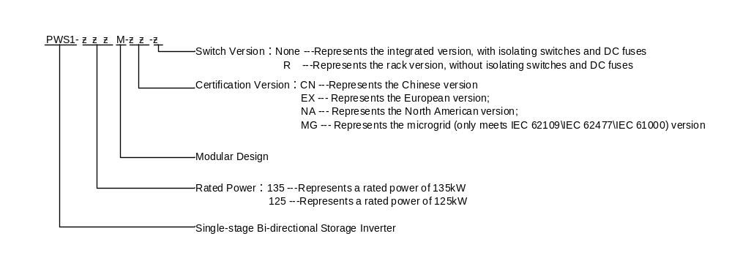Figure 1.1 The Product Code Definition
*Note: Fill in the corresponding numbers and letters to get the corresponding version. The internal components and parameter settings of different regional versions are different. Check the nameplate on the PCS to determine the model.
For example:
PWS1-135M-NA: represents the North American version of the 135kW integrated high-voltage box single-stage bi-directional storage inverter module.
PWS1-135M-MG-R: represents the version of the 135kW single-stage bi-directional storage inverter module for microgrids, which only meets IEC 62109\IEC 62477\IEC 61000 and omits the disconnector and DC fuse.
This document applies to the following existing product models:
• PWS1-135M-EX
• PWS1-135M-EX-R
• PWS1-125M-EX
• PWS1-125M-EX-R
•PWS1-100M-EX
•PWS1-100M-EX-R
Note:100、125kW is only available for Australian certification；
The product model number for the same performance section in this document is abbreviated as PWS1-135M.
The illustrations in this document are for schematic purposes only. Please refer to the actual products for details.

Made in China

1.2 Target User
The contents described in this document can only be operated by professionals.
Professionals are required to have the following skills:
- Understand how the product works and how to operate it
- Learn how batteries work and how to operate them
- Train and understand how to deal with hazards and risks that arise when installing and using electrical equipment
- Understand the installation and commissioning of electrical equipment and devices
- Understand all applicable standard operating instructions
- Understand and follow this manual and all safety information
the ACL statement:

Our goods come with guarantees that cannot be excluded under the Australian Consumer Law. You are entitled to a replacement or refund for a major failure and compensation for any other reasonably foreseeable loss or damage. You are also entitled to have the goods repaired or replaced if the goods fail to be of acceptable quality and the failure does not amount to a major failure

1.3 Terminology
Name | Definition
STS | Static Transfer Switch
AC | Alternating current
DC | Direct Current
BESS | Battery Energy Storage System
ESS | Energy Storage System
EMS | Energy Management System
BMS | Battery Management System
PCS | Power Conversion System
SLD | Single Line Diagram
SOH | State of Battery Health, expressed as a percentage
SCR | Silicon Controlled Rectifier
DOD | Depth of Discharge, expressed as a percentage
EOD | End of Discharge Cut-Off
SOC | State of Charge,or Remaining Power, expressed as a percentage
UI | User Interface
EPO | Emergency Power Off
SPD | Surge Protective Devices

2 Safety Information

2.1 Warning Signs
Sign | Explanation
 | Indicates a dangerous situation which, if not avoided, will result in serious injury or death.
 | Indicates a potential risk which, if not avoided, will result in personal injury or death
 | Indicates a dangerous situation which, if not avoided, may result in minor or moderate injury.
 | Indicates that property damage will occur if not avoided.
 | Please note important information, best practice and advice are detailed in the user manual. Note the information used to resolve issues not related to personal injury, equipment damage and environmental degradation.

2.2 Important Safety Instructions
This user manual for the installation and operation of the PWS1-135M series bi-directional storage inverter from Sinexcel.
Please read this user manual carefully before installation.
The bi-directional energy storage inverters must be commissioned and maintained by an engineer appointed by the manufacturer or an authorized service partner. Failure to do so may endanger personal safety and lead to equipment failure. Damage to the equipment caused as a result is not covered by the warranty.
Bi-directional energy storage inverters should not be used in any environment or application associated with life support equipment.
This manual contains important instructions for the PWS1 series models and these instructions should be followed when installing and maintaining the bi-directional energy storage inverter.


Any touching of the copper strip, contacts and terminals inside the appliance that are connected to the grid circuit may cause a fatal burn or electric shock!
Do not touch any terminals and wires connected to the grid circuit.
Take note of any instructions and safety documents regarding grid connection.


Contact with the interior of the appliance may present a risk of electric shock!
Any operation in connection with this appliance must be carried out by qualified personnel.
Please note the safety precautions listed in the safety instructions and installation documentation.
Please take note of the safety precautions listed in the operating and installation manuals and other documentation.

Massive power leakage.
Before connecting the input power, ensure that the earth is securely grounded.
The appliance must be earthed in accordance with local electrical codes.

When the battery is connected to a bi-directional energy storage inverter, DC voltage may be present at the input port. Please take care during operation or check the battery system user manual.

Do not touch live parts within 5 minutes of power failure!
Dangerous energy is stored in the internal capacitors, so do not touch the terminals, contacts, copper strip, etc. for 15 minutes after disconnecting the appliance from all power sources.

This device is not intended for use in residential environments and cannot provide adequate protection for radio reception in such environments!

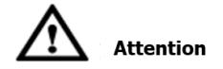
All internal maintenance and servicing of the equipment should be carried out by trained personnel. Internal components that require the use of tools to open cannot be maintained by the user.
Please read this user manual before operation

2.3 Additional Information
For further detailed information, please click: www.sinexcel.com.

3 Product Introduction

3.1 System Introduction
Bi-directional energy storage inverter (PCS) is a conversion device between the grid and the battery, which can charge and discharge the battery. It can invert the DC power from the battery into AC power that can be connected to the grid and rectify the AC power from the grid into DC power that can be charged into the battery. Bi-directional energy storage inverters can be used in grid-connected mode or off-grid mode. The N-PE contactor can be externally installed for grid-connected and off-grid switching.
The PWS1 series adopts a single-stage topology. The DC voltage input range is as follows:
PWS1-135M-EX: 600-1000Vdc@400Vac，
PWS1-135M-EX-R: 600-1000Vdc@400Vac，
PWS1-125M-EX: 600-1000Vdc@400Vac，
PWS1-125M-EX-R: 600-1000Vdc@400Vac.

3.2 System Schematic Diagram
The internal architecture of the PWS1-135M-EX/NA bi-directional storage inverter is a DC/AC four-bridge-arm topology. Figure 3.1 shows the topology of the system

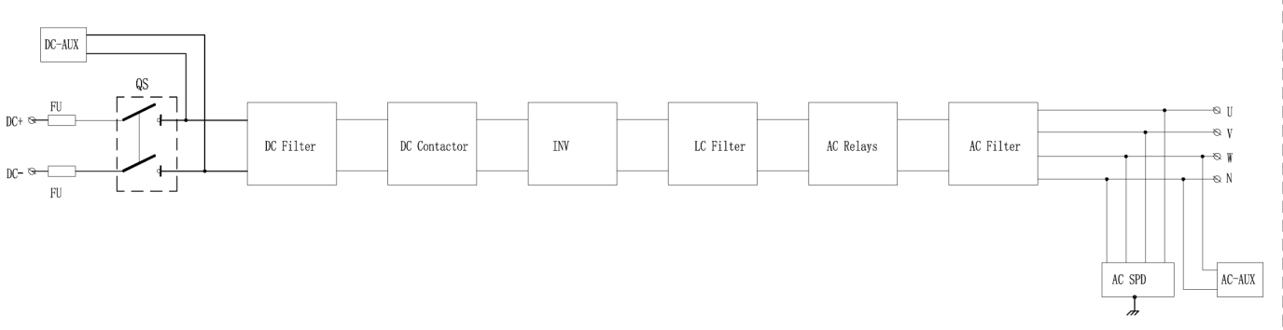

Figure 3.1 Pws1-135M Bi-directional Storage Inverter Topology Diagram

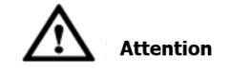
PWS1-135M module is equipped with disconnectors and fuses on the DC side, while there are no fuses or circuit breakers on the AC side. If grid-connected/grid-off switching is required, an external N-PE contactor can be configured. External protection and cut-off devices need to be configured. For details, please refer to Section 6.5.1.13.

The internal architecture of the PWS1-135M-EX/NA-R bi-directional storage inverter is a DC/AC four-bridge-arm topology. Figure 3.2 shows the topology of the system

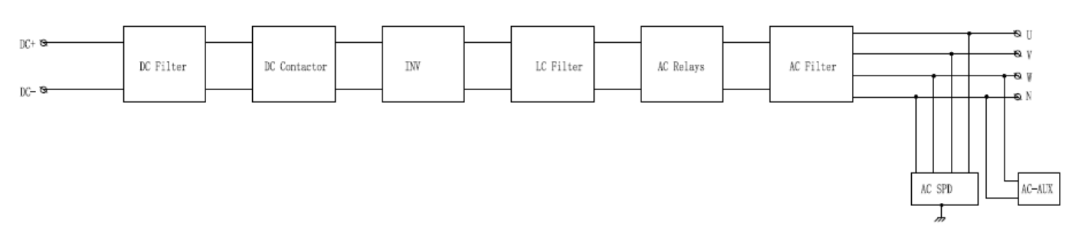
Figure 3.2 Pws1-135M Bi-directional Storage Inverter Topology Diagram

PWS1-135M-R module is not equipped with circuit breakers and fuses on the DC side, while there are no fuses or circuit breakers on the AC side. If grid-connected/grid-off switching is required, an external N-PE contactor can be configured. External protection and cut-off devices need to be configured. For details, please refer to Section 6.5.1.13.

3.3 PCS Panel Interface Definition
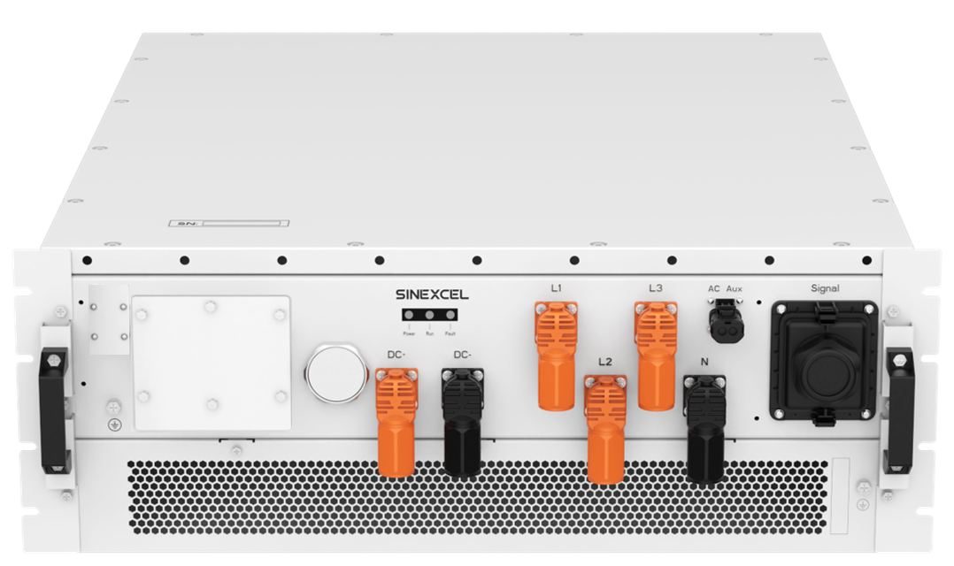
Figure 3.3-1 The Appearance of PCS (-R Version) Module (without Outer Cover and with Standard Handle)
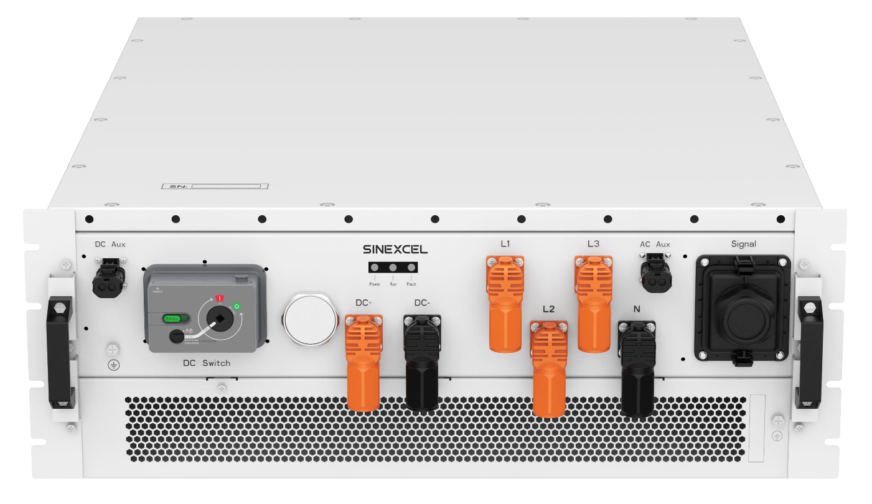
Figure 3.3-2 The Appearance of PCS Module (without Outer Cover and with Standard Handle)
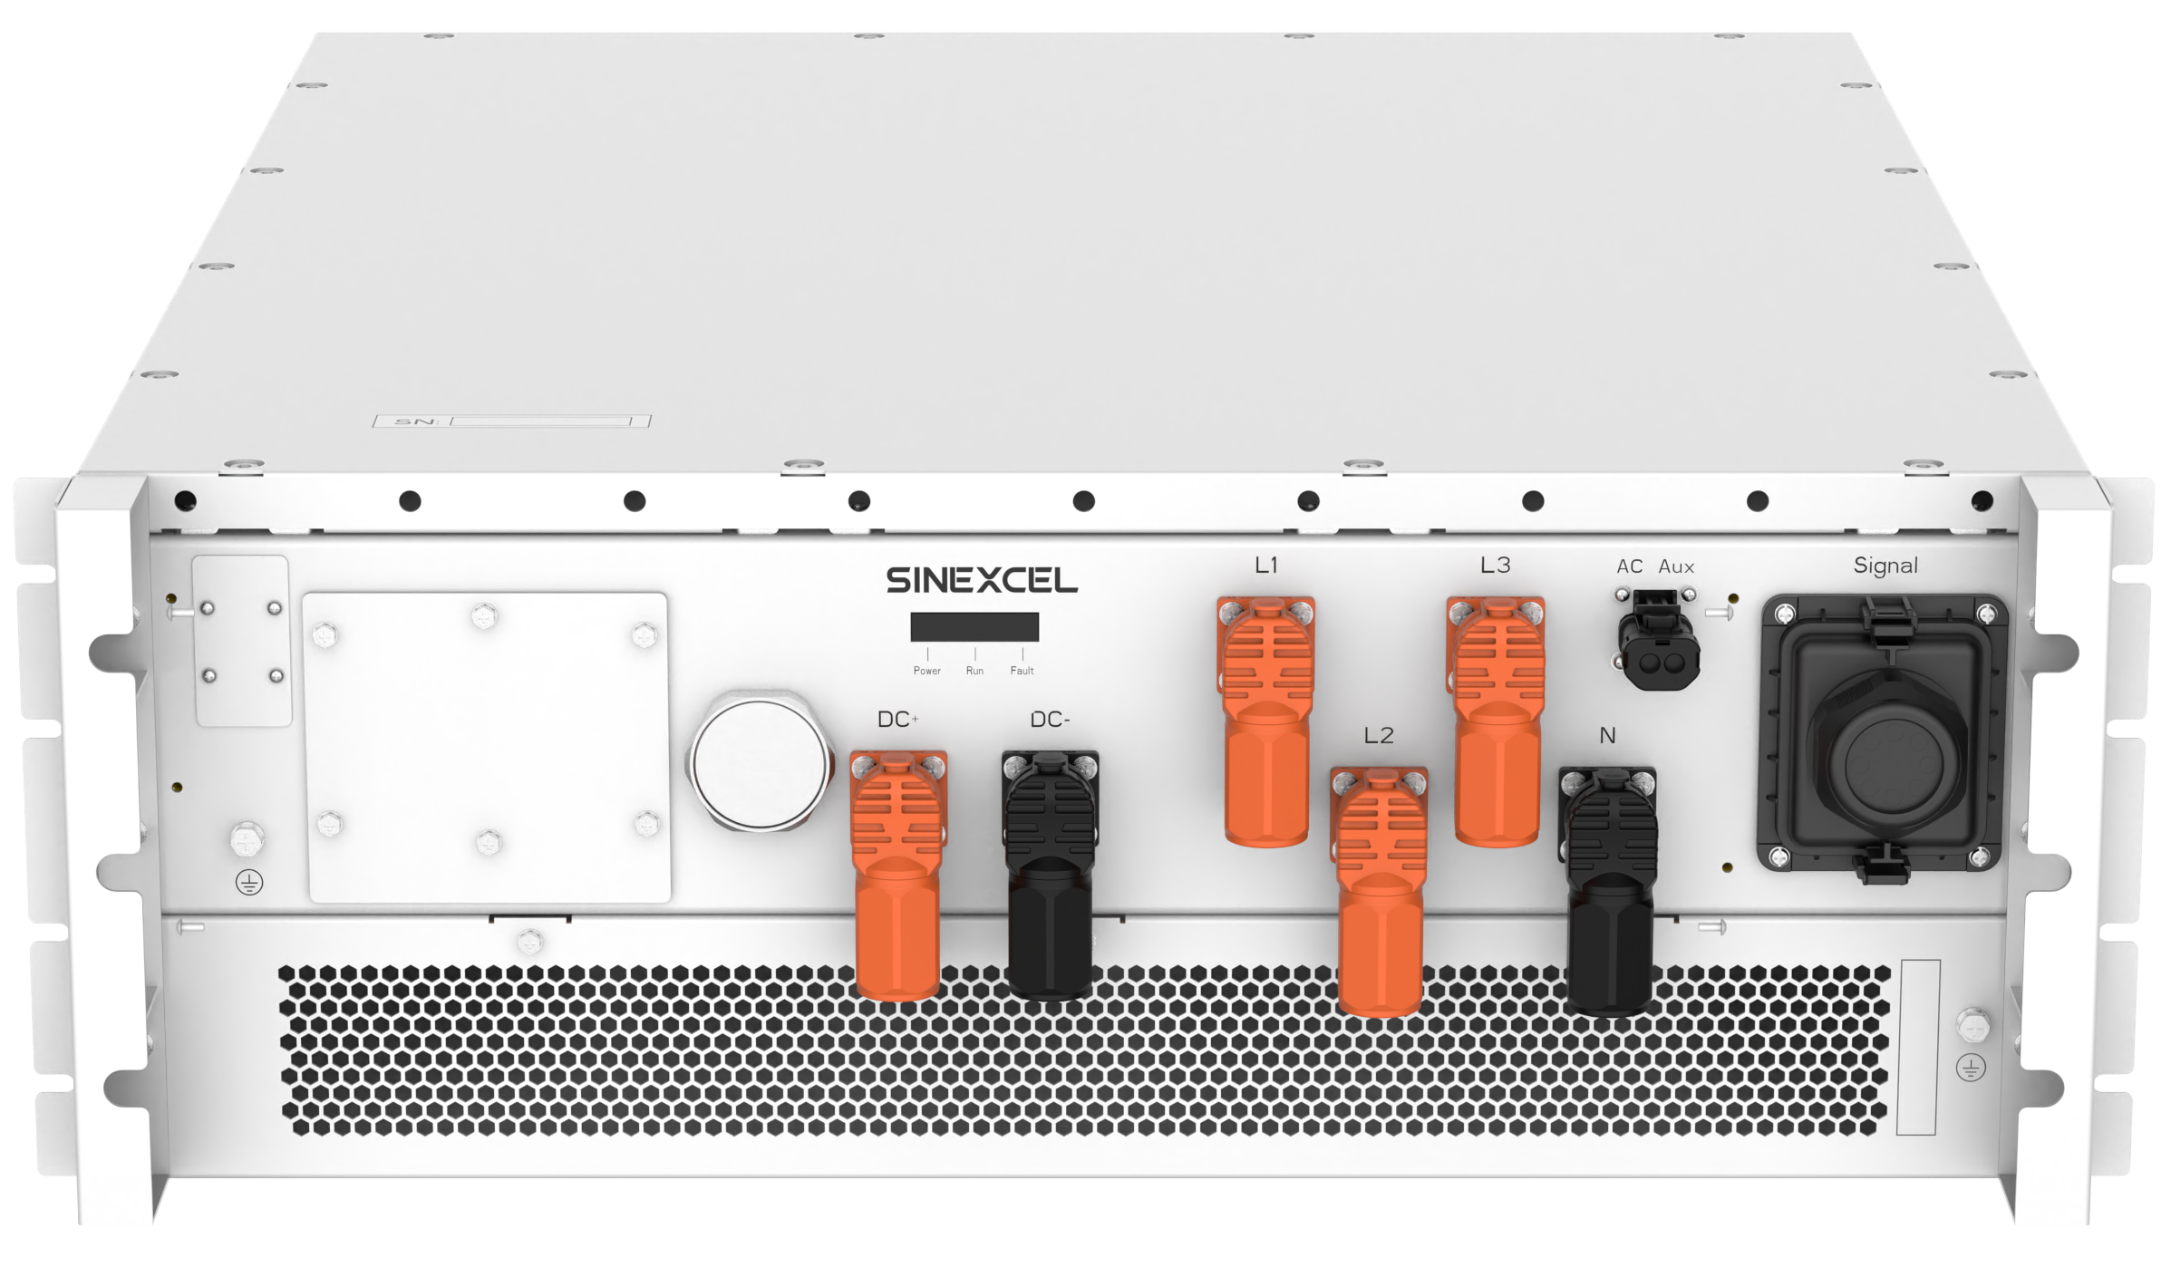
Figure 3.3-3 The Appearance of PCS (-R Version) Module (without Outer Cover and with Hoisting Handle)
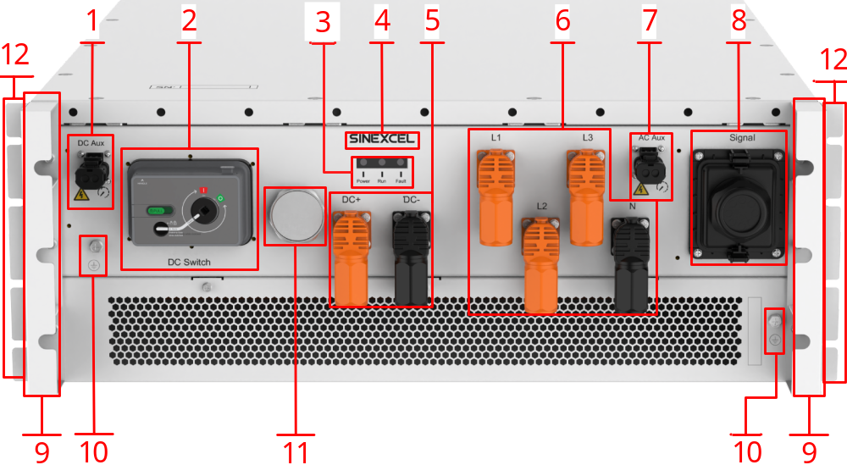
Figure 3.3-4 The Appearance of PCS Module (without Outer Cover and with Hoisting Handle)

Table 3-1 The Table of Panel Interface Definition
Serial Number | Name | Description
1 | DC-side Auxiliary Interface  (The -R version is omitted.) | External DC power supply (such as BMS sampling, etc.)  --With a current carrying capacity of 10A  --Same as battery voltage  --Internal fuses are equipped  --High Voltage Danger & 5min discharge warning printed on the underside.
2 | DC-side Switch(The -R version is omitted.) | Switch operation panel
3 | Panel Indicator Light | Power：Module power indicator (stays green when powered on).  Run：Module running status indicator (stays green during operation).  Fault：Module fault indicator (flashes red for alarm; stays red for fault).
4 | Mark | Sinexcel module logo
5 | DC-side Power Interface | DC-side power cable interface
6 | AC-side Power Interface | AC-side power cable interface
7 | AC-side Auxiliary Interface | --External AC power supply (power extraction for liquid-cooled unit)  --20A current carrying capacity, external 25A, 500V fuse required (considering ambient temperature derating).  --Power extraction is from the CN phase of the AC input, and the output voltage is equal to the CN phase voltage of the AC input  --High Voltage Danger & 5min discharge warning printed on the underside.  *Only supports the three phase four wire connection method.This interface is invalid for three phase three wire systems
8 | Signal Interface | The interface includes：  - Parallel machine communication and synchronization signals  - RS485/CAN communication and terminal matching resistors  - Input/output dry contacts/EPO/DRM0  - LAN  - 24V power supply for BMS, the power limit is 20W, switch control, Hall communication, etc. (for externally mounted integrated BMS version)
9 | Handle | Standard handle: Equipped with independent body hoisting lugs, handle only for push-pull module;  Hoisting handle version: the handle is reinforced for temporary hoisting during installation .
10 | Grounding Screw | Module enclosure grounding
11 | Pressure Relief Valve | Pressure protection
12 | Lifting lug | For installation and fixation of the standard handle version  (The hoisting handle version cancels the lifting lugs)

- Type of the compatible battery (Chemistry)：Lead-acid/LPF/Liquid-flow/Lithium battery/Super capacitor
- Voltage (range) for DC Aux port：600Vdc~1000Vdc
- Rated current for DC Aux port：10Adc max
- Rated Output Power (VA) for AC output port：135kVA（PWS1-135M-EX）；125kVA（PWS1-125M-EX）
- Rated Output Current (A) for AC output port;195Aac（PWS1-135M-EX）；181Aac（PWS1-125M-EX）
- Current (inrush) (peak and duration) for AC output port:20kA， 8/20us
- Maximum output fault current (peak and duration) for AC output port ：335Arms 200ms
- Rated Output Power (VA) for AC Aux port:4.6kVA
- Rated Output Current (A) for AC Aux port:20A
- Voltage (range) for AC Aux port:340~460Vac
- Frequency (range) for AC Aux port:-45~55Hz
- Power factor range for AC Aux port:-1~-0.8,0.8~1
- Protective Class:CLASS I
- Overvoltage Category :CLASS III（main）；CLASS II（DC）
- Active anti-islanding method：Active Frequency Shift Method

4 Technical Specification and Working Status

4.1 Parameter
Table 4-1 PWS1-135M-EX (-R)
Model | PWS1-135M-EX (-R)
AC Parameters
Rated AC Power | 135 kW
AC Connection | 3P4W+PE (230/400Va.c.)/ 3P3W+PE (400Va.c.)
AC Overload Capacity | 1.1 times for long term, 1.2 times for 1 minute
Utility-interactive Mode
AC Voltage | 400/380（340~460）Vac
AC Frequency | 50（-5~5）Hz
THDi | ≤3%
Voltage Ripple Coefficient | ≤1%
AC PF | -1~-0.8,0.8~1
DC Parameters
Maximum DC Power | 135 kW
DC Voltage Range | 600~1000（720~1000 @Full load）Vdc
Number of DC branches | 1
Maximum DC Current | 193A
Voltage Regulation Accuracy | ≤±1%
Current Regulation Accuracy | ≤±1%
System Parameters
Rated Power Point Conversion Efficiency | ≥98%
Dimensions (Width x Height x Depth) | 720*265*960mm (excluding mounting ears and signal waterproof cover)  762*265*990mm(Includes ear hook and signal waterproof cover)
Weight | ≤115 kg
Noise | ≤75 dB
Enclosure | IP66
Operation Temperature | -40~60℃(≥55℃ power derating)
Cooling | Intelligent Air Cooling
Operation Humidity | 0~100%（No condensation）
Operation Altitude | 3000m（＞3000m derating）
Display and Communication
Communication | RS 485，Ethernet，CAN
Communication Protocol | Modbus TCP/RTU,IEC 104, CAN 2.0
BMS | Support

Table 4-2 PWS1-135M-EX-R
Model | PWS1-135M-EX-R
AC Parameters
Rated AC Power | 135 kW
AC Connection | 3P4W+PE (230/400Va.c.)/ 3P3W+PE (400Va.c.)
AC Overload Capacity | 1.1 times for long term, 1.2 times for 1 minute
Utility-interactive Mode
AC Voltage | 400/380（340~460）Vac
AC Frequency | 50（-5~5）Hz
THDi | ≤3%
Voltage Ripple Coefficient | ≤1%
AC PF | -1~-0.8,0.8~1
DC Parameters
Maximum DC Power | 135 kW
DC Voltage Range | 600~1000（720~1000 @Full load）Vdc
Number of DC branches | 1
Maximum DC Current | 193A
Voltage Regulation Accuracy | ≤±1%
Current Regulation Accuracy | ≤±1%
System Parameters
Rated Power Point Conversion Efficiency | ≥98%
Dimensions (Width x Height x Depth) | 720*265*960mm (excluding mounting ears and signal waterproof cover)  762*265*990mm(Includes ear hook and signal waterproof cover)
Weight | ≤115 kg
Noise | ≤75 dB
Enclosure | IP66
Operation Temperature | -40~60℃(≥55℃ power derating)
Cooling | Intelligent Air Cooling
Operation Humidity | 0~100%（No condensation）
Operation Altitude | 3000m（＞3000m derating）
Display and Communication
Communication | RS 485，Ethernet，CAN
Communication Protocol | Modbus TCP/RTU,IEC 104, CAN 2.0
BMS | Support

Table 4-3 PWS1-125M-EX
Model | PWS1-125M-EX
AC Parameters
Rated AC Power | 125 kW
AC Connection | 3P4W+PE (230/400Va.c.)/ 3P3W+PE (400Va.c.)
AC Overload Capacity | 1.1 times for long term, 1.2 times for 1 minute
Utility-interactive Mode
AC Voltage | 400（340~460）Vac
AC Frequency | 50（-5~5）Hz
THDi | ≤3%
Voltage Ripple Coefficient | ≤1%
AC PF | -1~-0.8,0.8~1
DC Parameters
Maximum DC Power | 125 kW
DC Voltage Range | 600~1000（665~1000 @Full load）Vdc
Number of DC branches | 1
Maximum DC Current | 193A
Voltage Regulation Accuracy | ≤±1%
Current Regulation Accuracy | ≤±1%
System Parameters
Rated Power Point Conversion Efficiency | ≥98%
Dimensions (Width x Height x Depth) | 720*265*960mm (excluding mounting ears and signal waterproof cover)  762*265*990mm(Includes ear hook and signal waterproof cover)
Weight | ≤115 kg
Noise | ≤75 dB
Enclosure | IP66
Operation Temperature | -40~60℃(≥55℃ power derating)
Cooling | Intelligent Air Cooling
Operation Humidity | 0~100%（No condensation）
Operation Altitude | 3000m（＞3000m derating）
Display and Communication
Communication | RS 485，Ethernet，CAN
Communication Protocol | Modbus TCP/RTU,IEC 104, CAN 2.0
BMS | Support
Note: PWS1-125M-EX is for Australian parameters.

Table 4-4 PWS1-125M-EX-R
Model | PWS1-125M-EX-R
AC Parameters
Rated AC Power | 125 kW
AC Connection | 3P4W+PE (230/400Va.c.)/ 3P3W+PE (400Va.c.)
AC Overload Capacity | 1.1 times for long term, 1.2 times for 1 minute
Utility-interactive Mode
AC Voltage | 400（340~460）Vac
AC Frequency | 50（-5~5）Hz
THDi | ≤3%
Voltage Ripple Coefficient | ≤1%
AC PF | -1~-0.8,0.8~1
DC Parameters
Maximum DC Power | 125 kW
DC Voltage Range | 600~1000（665~1000 @Full load）Vdc
Number of DC branches | 1
Maximum DC Current | 193A
Voltage Regulation Accuracy | ≤±1%
Current Regulation Accuracy | ≤±1%
System Parameters
Rated Power Point Conversion Efficiency | ≥98%
Dimensions (Width x Height x Depth) | 720*265*960mm (excluding mounting ears and signal waterproof cover)  762*265*990mm(Includes ear hook and signal waterproof cover)
Weight | ≤115 kg
Noise | ≤75 dB
Enclosure | IP66
Operation Temperature | -40~60℃(≥55℃ power derating)
Cooling | Intelligent Air Cooling
Operation Humidity | 0~100%（No condensation）
Operation Altitude | 3000m（＞3000m derating）
Display and Communication
Communication | RS 485，Ethernet，CAN
Communication Protocol | Modbus TCP/RTU,IEC 104, CAN 2.0
BMS | Support
Note: PWS1-125M-EX-R is for Australian parameters.

Application environment restrictions:
Works in stand-alone mode (off-grid mode), there are some restrictions on the application environment.
• The parallel connection of multiple bi-directional energy storage inverter is a customized function. When users need to connect the AC outputs in parallel in off-grid mode, please contact the manufacturer.
• The load power of resistor < rated power of PCS
• The load power of RCD (resistor - capacitor - diode)< 60% of the apparent power of a single PCS unit. When there are RCD loads, please contact the manufacturer to confirm the PCS capacity configuration.
• For motor loads with frequency inverters, the load power < apparent power of a single PCS unit.
• For motor loads without frequency inverters, please contact the manufacturer to confirm the PCS capacity configuration. The specific load power of motor that can be carried shall be determined according to the actual on site load conditions, and it is necessary to communicate with our company's technical personnel.
• It is recommended that the maximum load current is less than the rated current of the PCS.

4.2 Working Status
PWS1-135M bi-directional storage inverter has several states such as “Initial shutdown” ,”Shutdown”, “Running”, “Fault”, “Emergency shutdown”, “Standby” and so on.
▲ Initial shutdown
In this state, the system performs a self-test. When the self-test is passed, the inverter is transferred from the initial shutdown mode to the shutdown mode.
▲ Shutdown
When the bi-directional storage inverter does not receive any operation command or dispatch, the system is in shutdown mode. In shutdown mode, the inverter receives operation instructions and scheduling from the host computer, and when the operating conditions for operation are met, the equipment is transferred from shutdown to operation mode.
During operation, if a "shutdown" command is received, the bi-directional storage inverter is transferred from operation to shutdown.
▲ Running
The running mode is divided into charging and discharging. In grid-connected mode, the bi-directional storage inverter is capable of active as well as reactive power control.
▲ Fault
PWS1-135M bi-directional storage inverter has a comprehensive fault detection function, including built-in ground fault detection, and the fault type can be divided into two categories: "shutdown fault" and "non-shutdown fault". When "shutdown fault" occurs, the system enters the shutdown state; when "non-shutdown fault" occurs, the webpage of the bi-directional storage inverter issues alarm information in the background, but does not stop the operation state.
▲ Emergency shutdown
When the EPO dry contact is disconnected at the critical moment, the equipment enters the emergency stop state, and when it needs to enter the operation state again, the EPO dry contact must be turned.
▲ Standby
In this state, the DC contactors of the bi-directional storage inverter are closed and the internal auxiliary power supply of the machine is in working condition, and the AC-side switch operates in different states according to the settings of Control Parameter 6 on the monitoring interface.
Operation Guide for Control Parameter 6 Settings:
Parameter Setting Options:
1005: Enter standby mode without disconnecting the AC side. The device will maintain connection and will not disconnect actively.
1006: Enter standby mode and disconnect the AC side after 4s. Upon receiving the standby command, the device will enter standby mode and execute the AC-side disconnection operation after 4s.
0: Enter default state. When the device enters the default standby mode, it will disconnect the AC side after 5 min.
Key Safety Operation Recommendations:
For applications where the BMS does not transmit shutdown signals to the PCS, the 1006 setting must be adopted.
This prevents voltage or current surges that could damage the PCS device, which are caused by the DC-side being accidentally disconnected (rendering the PCS unable to identify the status) and then reconnected during standby mode. The 1006 setting ensures that after a standby command is issued, the system disconnects safely within an extremely short period (4s), eliminating the risk of the DC-side being reconnected when the PCS is in an unready state.
If the BMS is capable of transmitting shutdown signals, it must send fault signals to the PCS via communication links or fault dry contacts.

An inverter with storage connections will need to provide a means for temperature compensation of the battery charge voltages. This is particularly important for use with lead acid batteries in warm climates, to avoid damage to battery banks by overcharging in hot weather, and related hazards due to release of hydrogen gas and cell rupture. Most stand-alone inverters control this function via a remote temperature sensor which is attached to the battery bank.

The PWS1-135M does not include a connection terminal for a remote battery temperature sensor. If installing PWS1-135M with lead acid batteries please check with SINEXCEL for advice regarding charge settings.

4.3 Operating State Switching
PWS1-135M series bi-directional storage inverters can be switched between different modes, and the switching conditions that need to be met are shown in Figure 4.1.
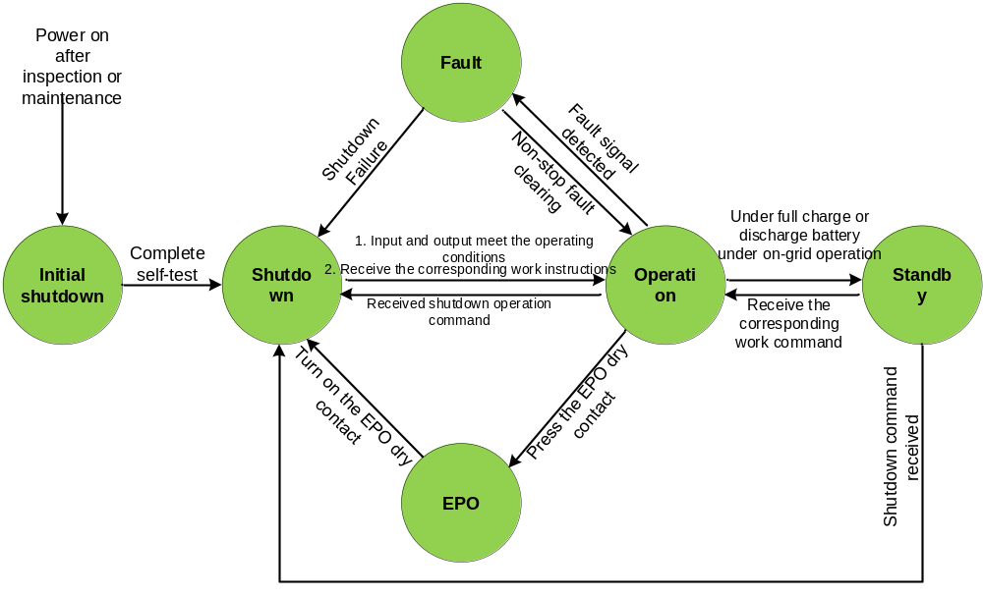
Figure 4.1 PCS Switching between Different Working States

4.4 Operating Mode Introduction
The operating modes of the bi-directional storage inverter can be divided into grid-connected charging, grid-connected discharging, off-grid charging and off-grid discharging. Whether in grid-connected or off-grid mode, the charging and discharging conversion can be carried out directly, while the conversion of grid-connected and off-grid mode needs to go through the shutdown state.

4.5 Main Functions
PWS1-135M bi-directional storage inverter has the following functions:
- Off-grid and Grid-connected Control
bi-directional storage inverter can operate in either grid-connected or off-grid modes. In the grid - connected mode, the AC side follows the grid voltage, while in the off-grid mode, it outputs a constant frequency and constant voltage AC power. 
- Charging and Discharging Control
bi-directional storage inverter is capable of charging and discharging battery packs. The charging power and discharging power can be set by the user. 
- Reactive Power Control
bi-directional storage inverter can control the power factor and reactive power ratio. This function can be achieved during both charging and discharging operations. Users can set the reactive power through the webpage. 
- Output Voltage and Frequency Stabilization
In a grid-connected system, bi-directional storage inverter can adjust and stabilize the output voltage and frequency by controlling reactive power and active power. To achieve this function, a large scale energy storage power station needs to be established.

5 Storage, Handling and Transportation

5.1 Transportation and Storage
When transporting and storing the inverter cabinet, please pay attention to the markings on the packaging boxes. The transportation and storage processes should meet the following requirements:
- Do not remove the outer packaging of the inverter;
- Ensure there are no corrosive gases in the surrounding environment;
- Maintain the storage temperature between -40°C and 70°C, and the relative humidity between 0% RH and 100% RH, with no condensation;
- Keep in a non dusty environment;
- Stack no more than 3 layers;
- During storage, conduct regular inspections. If there is any damage from insects or rodents, replace the packaging materials in a timely manner;
- Comply with fire protection requirements;
- If the storage time exceeds half a year, the inverter must be inspected and tested by professionals before it can be put into use.

The illustration of the packaging markings is shown in Table 5-1:

Table 5-1 Explanation of Packaging Markings（if so）
Icon | Description
 | Center of gravity mark, indicating the center of gravity of the bi-directional storage inverter.
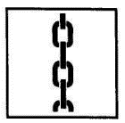 | Lifting mark, indicating the position of the chain or rope when lifting the bi-directional storage inverter
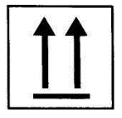 | The upward mark indicates the placement method when carrying and placing the bi-directional storage inverter. It is strictly forbidden to put it upside down, horizontally or tilted.
 | Handle the logo with care, and avoid violent friction or collision during transportation and placement.
 | During transportation and storage, the bi-directional storage inverter should be protected from rain or moisture.
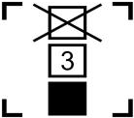 | Stack labels; avoid exceeding the specified number during placement.


Please avoid transporting the bi-directional storage inverter under rain or bad weather conditions. If it is unavoidable, please take necessary protective measures.

5.2 Unpacking Inspection
Each module has undergone strict factory inspection and testing. To prevent damage during transportation, unpacking inspection is required before the energy storage device is ready for installation. The main inspection contents are as follows:
- Check whether the quantity of each item on the packing list is consistent with the actual item;
- Check whether the nameplate data of the product is consistent with the order contract, such as product model, rated capacity, voltage level, etc.;
- Check whether the factory documents and accessories are complete;
- Check whether the appearance of the bi-directional storage inverter is consistent with the description in this manual;
- Check the bi-directional storage inverter for deformation, peeling paint and loose parts.
Note: Subject to actual product packing list

Table 5-2 Standard Configuration
Name | Quantity | Remarks
User Manual | 1 | Electronic document
FAT Report | 1
Certificate of Conformity | 1
Accessory Kit | 1
Electronic documents can be downloaded from Sinexcel website or provided by Sinexcel staff.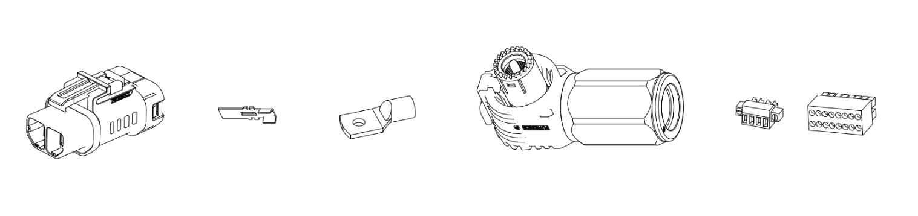
Table 5-3 Accessory Kit
Serial Number | Name | Quantity | Remarks
1 | Power terminal | 6 pcs | 4 red and 2 black
2 | Ground Wire Crimp Terminals | 2 pcs | Adapted to 35mm² grounding wire
3 | DC Power taking Rubber shell Male Connector | 1 pcs | DC power taking socket matching terminal
4 | DC Power taking Crimp Terminals | 2 pcs | DC power taking socket matching cable crimp terminal
5 | AC Power taking Rubber shell Male Connector | 1 pcs | AC power taking socket matching terminal
6 | AC Power taking Crimp Terminals | 1 pcs | AC power taking socket matching cable crimp terminal
7 | COM1 Phoenix Terminal | 1 pcs | COM1 matching terminal
8 | Plug-in Terminal | 3 pcs | COM2, COM3, COM4 matching terminals

5.3 Precautions for Handling
Modules should not be manually carried directly. Machinery should be used for handling.
Note: The front handle cannot be used for bearing weight. This handle is used for pulling out and pushing in the module and cannot be used for carrying.

6 Equipment Installation

6.1 Installation Process
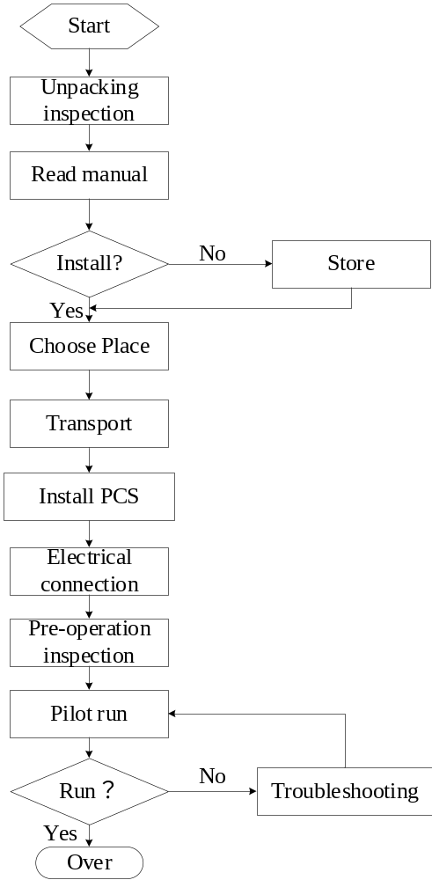
Figure 6.1 Installation process

Table 6-1 Installation Process Overview
Process | Chapter | Illustrate
Transport Preparation | 5 | Storage, Handling and Transportation
Equipment Installation | 6 | Equipment Installation
Electrical Installation | 6 | Electrical Connection
After-installation Inspection | 6 | Installation Checklist
Debug Startup and Operation | 9 | Start up and Running

6.2 Installation Notes
The live parts of the equipment are high voltage and touching them may result in death or serious injury from electric shock.
Please wear appropriate personal protective equipment for work.
Do not touch any live parts.
Observe all warnings that appear on the equipment and in the documentation.
Follow all safety information provided by the battery manufacturer.

Touching the DC cables may cause a risk of electric shock.
The DC cable connected to the battery is live. Contact with live cables may result in death by electric shock or serious injury. Before connecting the DC cable, make sure that there is no voltage on the DC cable.
Please wear appropriate personal protective equipment for work.


Entering the storage system creates a risk of electric shock.
Insulation damage in the storage system can cause fatal ground currents that can result in electric shock. Ensure that the insulation resistance of the storage system exceeds the minimum value. Insulation resistance minimum:1MΩ.
The bi-directional storage inverter must be installed in a closed electrical operating area.

Failure to adhere to torque specifications when bolting can cause fires.
Failure to comply with the specified torque will reduce the load-bearing capacity of the bolted connection and thus increase the contact resistance value.
May cause local overheating and fire.
Make sure to always tighten the bolted connections using the torque specified in this document.
When working on equipment, use only the correct tools.
Avoid repeatedly tightening the bolts as this may result in unacceptably high torques.

6.3 Preparation for Installation
The overall dimensions of the PWS1-135M series bi-directional storage inverter are shown below. Please refer to the latest drawings for details.
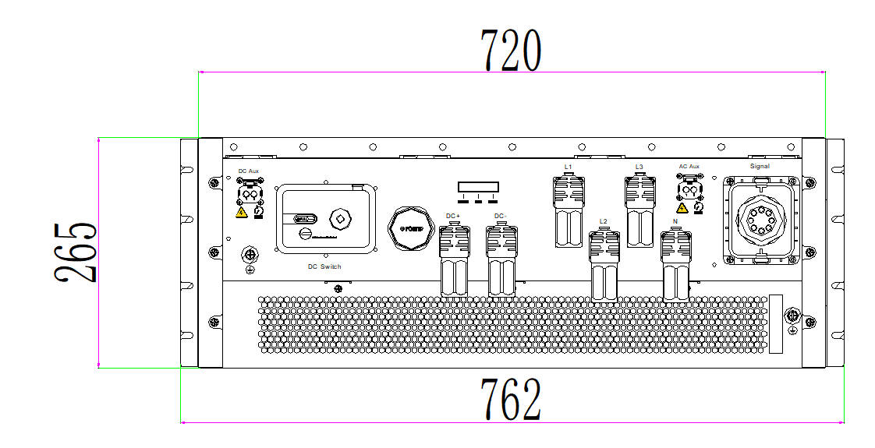
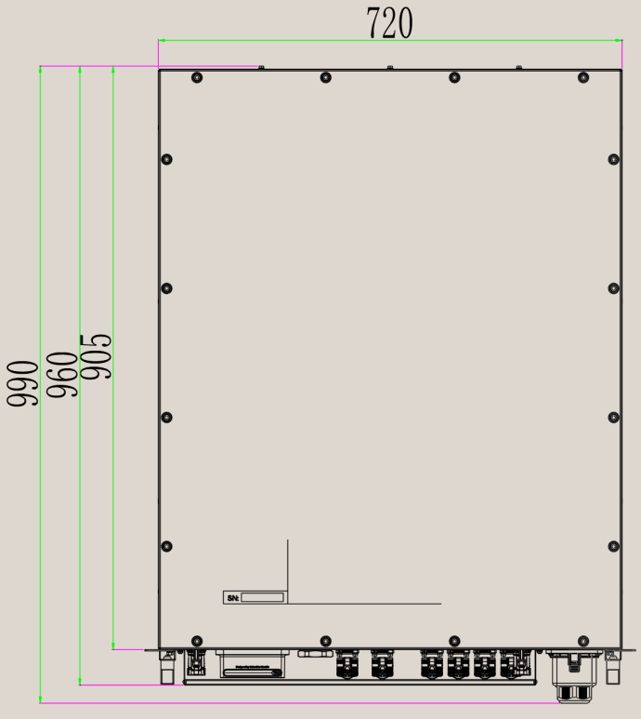
(a)Flat Installation (recommended installation method)
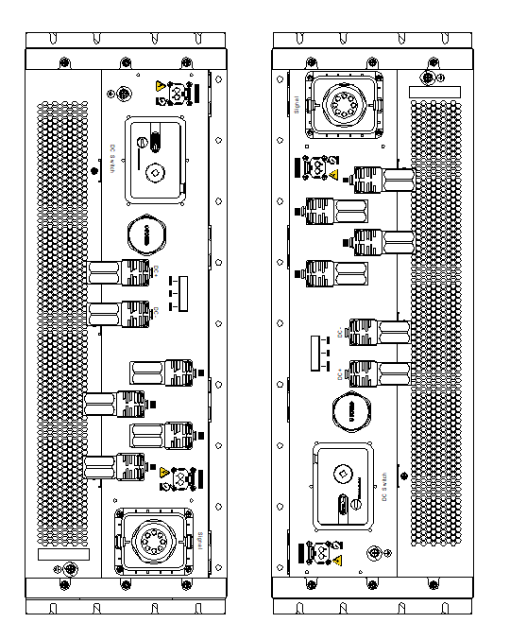
(b) Vertical Installation
Figure 6.2 Bi-directional Storage Inverter Outline Dimensions

6.4 Installation Requirements

6.4.1 Environmental Requirements
- The installation environment should be clean, avoiding a large amount of dust in the air，Avoid chemical substances and corrosive gases；
- Install it in an environment with good ventilation to ensure good heat dissipation;
- Avoid blocking the air inlet and outlet to ensure smooth air ducts;
- The ambient temperature should be maintained between -40°C and 60°C to ensure the optimal operating condition of the inverter. Temperatures that are too high or too low will shorten its lifespan;
- Do not install it outdoors in salt-affected areas, which mainly refer to coastal areas within 500m of the coastline. The deposition amount of salt fog is related to the characteristics of the adjacent sea water, sea breeze, precipitation, air humidity, terrain, and forest coverage, with significant differences;
- When the energy storage power inverter is in operation, it will generate some noise, so it is not recommended to install it in living areas;
- It is strictly prohibited to install the equipment in areas with strong vibration, strong noise sources, and strong electromagnetic field interference.

6.4.2 Carrier Requirements
- The inverter installation carrier must have fire-proof properties.
- Do not install the inverter on flammable building materials.
- Please ensure that the mounting surface is solid and meets the load-bearing requirements for installing the inverter.
- Ensure installation on a stable surface. Vehicle-mounted use and long-term mobile use are prohibited.
- Cabinet/rack dimensional requirements：Module outline dimension: 720 (W)×265 (H)×960 (D) (without mounting lugs & signal waterproof cover); 762 (W)×265 (H)×990 (D) (with mounting lugs & signal waterproof cover). Cabinet internal space shall reserve the module overall dimension plus heat dissipation clearance; cabinet front/rear door must be equipped with ventilation mesh to meet 1.2×650CFM total air volume demand o the module.
- Clearances when installed inside a cabinet:
  - Front: ≥250mm
  - Sides: ≥100mm
  - Rear: ≥250mm
  - Top & bottom: ≥10mm
- Load-bearing requirement：Single module weight ≤115kg; cabinet mounting carrier must be fireproof solid metal structure, load capacity ≥150kg per module position; flammable building materials are prohibited as mounting base.
- IP rating matching：The module itself is IP66; the cabinet shall meet at least IP54, and IP66 is recommended for coastal or dusty sites.
- Heat dissipation & installation clearance limit：Baffle distance before module air inlet /after air outlet ≥250mm; front maintenance space ≥600mm; rear air exhaust unobstructed; left/right side clearance ≥100mm per module. Top clearance ≥10mm (minimum spacing above the inverter/PCS). Bottom clearance ≥10mm (minimum spacing below the inverter/PCS)
Thermal Note: The actual cooling recommendation shall be determined upon completion of system thermal simulation and thermal testing.
- Detailed Mechanical Mounting Information (Rack/Cabinet Mounting)
- Mounting hole layout & quantity ：Mounting lugs are reserved on both left and right sides of the module, 3 mounting holes per side, total 6 mounting holes for cabinet fixing.
- Mounting hole dimension：Standard mounting hole for M10 bolt; hole position reserved on the 762mm width mounting ear of the module.
- Fixing method：Use M10 high-strength bolts + flat washers + spring washers to fasten the module mounting lugs to the cabinet beam; no rail mounting, direct bolt fastening is adopted.
- Installation restriction：The front pull-out handle of the module is only for pushing/pulling the module and cannot bear the weight of the inverter; hoisting lugs are only for hoisting during handling.

For non-standard environmental applications, please contact Sinexcel.

6.4.3 Ventilation Requirements
The cooling method of the bi-directional storage inverter adopts forced air cooling. The module has an independent heat dissipation air duct, with the module's heat dissipation mode being front -inlet and rear-outlet. The required cold air is suctioned through the mesh holes of the front door of the cabinet, and the hot air after absorbing heat is exhausted through the mesh holes of the rear door of the cabinet.
When installing the module, the air intake should be ensured, and appropriate space should be left for air inlet and outlet. It is required that the air outlet meets the system air-volume demand in Table 6-2 to ensure that the heat dissipated by the bi-directional storage inverter is exhausted out.

Table 6-2 Air Volume Required for Heat Dissipation of PWS1-135M
Model | System Air volume Demand | Number of Module Fans | Inlet Area | Outlet Area
PWS1-135M | 650CFM | 6 | 25000 mm² | 25000 mm²

When the module is integrated in the cabinet, the module's inlet and outlet need to meet 1.2 times the system air volume demand, and the internal air ducts of the cabinet should not cross. If there is a sealed baffle in front of the module's inlet and outlet, the distance between the module's inlet and outlet and the baffle should be ≥250mm to ensure that the heat dissipated by the bi-directional storage inverter can be smoothly exhausted out of the cabinet.

6.5 Electrical Installation and Connection

6.5.1 Electrical Connection

6.5.1.1 Input Requirements
The Battery voltage of bi-directional storage inverter must be within PCS required input range, otherwise the bi-directional storage inverter will not work. When configuring the number of batteries in series, the user must fully consider the maximum charging voltage and the minimum discharging voltage. For details, please consult our technical service personnel.
In order to use PWS1-135M series (integrated DC disconnector + fuse) bi-directional storage inverter more safely and in a standardized manner, the recommended energy storage system configuration is as follows:
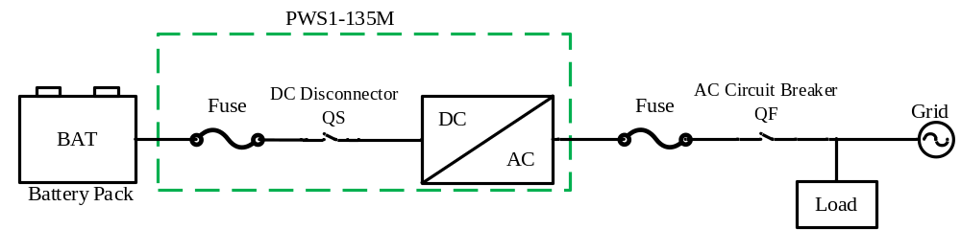Figure 6.3 Recommended Configuration
Note: This product does not have internal fuses/circuit breakers on the AC side, and users are required to configure external protection according to technical specifications，refer to section 6.5.1.13 for selection.

In order to use PWS1-135M-R series (non-integrated DC disconnector + fuse) bi-directional storage inverter more safely and in a standardized manner, the battery system used in conjunction with bi-directional storage inverter should be equipped with DC circuit breakers or a combination of DC disconnector and fuses and AC Circuit Breaker and Fuse. The recommended energy storage system configuration is as follows:
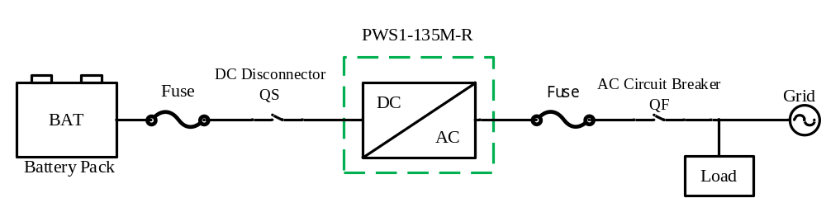
Figure 6.4 Recommended Configuration
Note: This product does not have internal fuses/circuit breakers on the AC side, no fuses/circuit breakers on the DC side and users are required to configure external protection according to technical specifications，refer to section 6.5.1.13 for selection.

This PCS unit is equipped with an internal residual current protector; an external Type B residual current protector may be optionally installed to meet the measurement requirements of a rated AC effective value of 1.35 Arms and a peak value of 2 A.
This PCS has only passed single-unit AS/NZS 4777.2:2020 testing. Multi-module parallel combinations have not been tested against Clause 5 of AS/NZS 4777.2:2020. If multi-PCS parallel grid-connected/off-grid operation is required, system design and external synchronization/protection devices shall comply with the requirements of AS/NZS 4777.1, and parallel scheme confirmation from Sinexcel technical support is mandatory before deployment.

Each DC input branch of multiple bi-directional storage inverter modules operates independently. If standard equipment requires parallel operation of the DC sides of multiple devices, please contact Sinexcel.

 | The energy storage device has no built-in isolation transformer;  If the capacity of the energy storage device fails to meet the requirements, multiple units can be connected in parallel. On the DC side, each inverter should be equipped with a battery of appropriate capacity, and the AC sides should be connected in parallel to the power grid. For parallel operation, it is necessary to communicate with our technical personnel to determine the scheme and its application.  For the parallel operation of two or more units with both DC and AC sides connected in parallel, it is necessary to communicate with our technical personnel to determine the scheme and its application.

6.5.1.2 Output Requirements
The PWS1-135M series bi-directional storage inverters do not contain transformers. The output is three-phase four-wire, and the output voltage is 380V/400V/480V/208V@70kW. It can be directly connected to the low voltage power grid. The output side should be equipped with an AC circuit breaker or a combination of an AC disconnector and a fuse, and external protection should be configured according to technical specifications.

6.5.1.3 Wiring Method
The bi-directional storage inverter adopts the front-to-front wiring method, and the cables are plugged in directly at the module panel using the corresponding pairs of terminals.For the requirements of the connecting cables, single or multiple cables with appropriate wire diameters should be selected. It is recommended that the current on a 1mm² wire be ≤4A.
The wiring method should comply with national electrical regulations or other local standards.
Use the factory equipped terminal housing for crimping and installation;

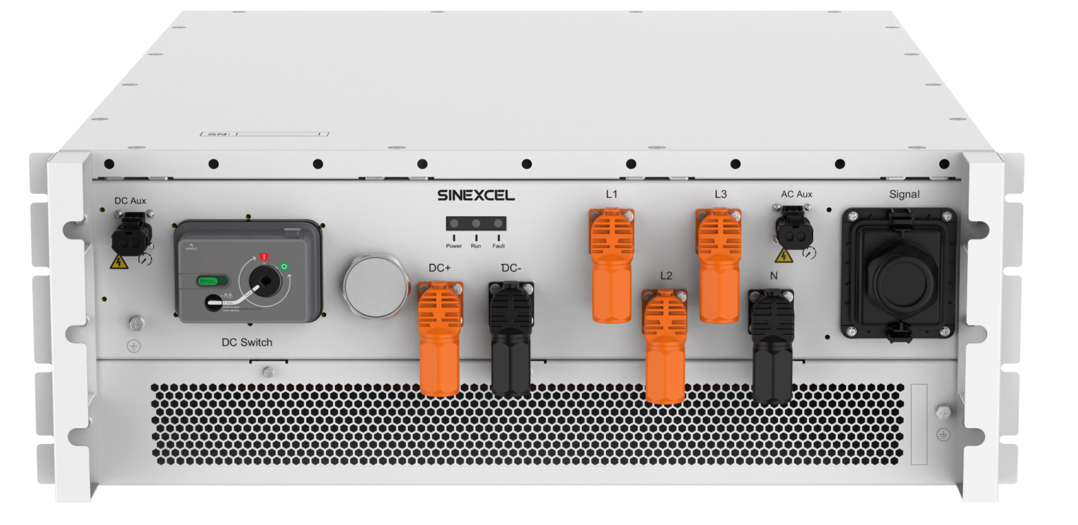
(1) Hoisting Handle Version
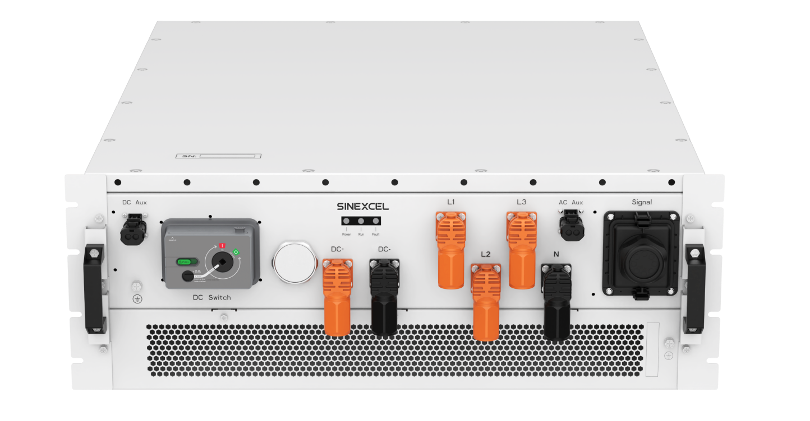
(2) Standard Handle Version
Figure 6.5 PWS1-135M Module Terminal Diagram
Table 6-3 PWS1-135M Wiring Copper Description
Location | Name | Description
DC+ | Battery positive terminal + | Battery positive input terminal
DC- | Battery negative terminal - | Battery negative input terminal
L1 | Phase A | AC phase A
L2 | Phase B | AC phase B
L3 | Phase C | AC phase C
N | N-Phase | AC phase N
 | Grounding | Protective grounding
DC Aux | High voltage DC (Battery voltage) | Fire power supply port
AC Aux | High voltage AC 230VAC | Power supply port for liquid cooling unit, taking U_{CN} voltage
Mandatory outer cover: After completing power terminal wiring, the module outer cover must be fully installed and locked; the cover mechanically blocks the plug release button to prevent accidental unplugging during operation;
Plug self-locking structure: Power plug has snap lock design, a clear "click" sound indicates full insertion; disconnection requires manual pressing of the unlocking button, no accidental falling off under vibration.

6.5.1.4 System Grounding
Connect the inverter to the grounding busbar through the protective grounding wire to achieve the purpose of grounding protection.
Cable and terminal specifications:
- Grounding cable: It is recommended to use an outdoor copper core cable with a cross sectional area of ≥35mm² (2AWG).
- OT terminal：M6.
Good grounding is beneficial for withstanding surge voltage impacts and improving EMI performance. Therefore, the grounding wire should be connected before connecting AC, DC, and communication cables.
It is recommended to ground the inverter nearby. For a multi-unit PWS1-135M parallel system, the grounding points of all inverters need to be interconnected to ensure equipotential connection of the grounding wires
Step 1: Use wire strippers to strip the insulation layer of the grounding cable to an appropriate length.
Step 2: Insert the core of the stripped insulation cable into the conductor crimping area of the OT terminal and crimp it tightly with a hydraulic crimper.
Step 3: Put the terminal on the grounding bolt and tighten it to a torque of 3Nm.
Caution: The recommended tightening torque for the module’s PE connection point is 3 Nm. Excessive torque may cause deformation of the internal copper busbar, so do not apply a torque exceeding 3 Nm.
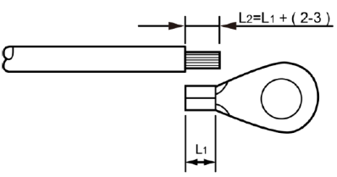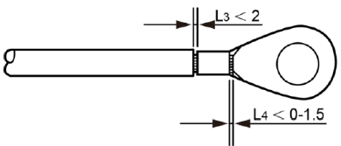
Figure 6.6 Wire Stripping Diagram

Table 6-4 Description of Grounding PE Cable
Rated Power | PE copper wire recommended value (mm²)
135/125kW | ≥Phase line cross-sectional area/2，35mm² is recommended. The rated temperature of the insulation sheath shall not be lower than 105℃.

Cabinets and modules need to be reliably grounded! The grounding resistance should be less than 4Ω.

6.5.1.5 DC side wiring
1) Measure the port voltage of the battery with a multimeter (note the range) to ensure that it is within the input voltage range of the bi-directional storage inverter;
2) Disconnect the DC switch of the previous level and measure with a multimeter to confirm that there is no voltage between the positive and negative terminals of the DC input before wiring operation.
3) Connect the positive terminal of the battery to the "DC+" of the DC input;
4) Connect the negative terminal of the battery to the DC input "DC-";
5) Make sure the wiring is secure

Table 6-5 PWS1-135M DC Side Cable Specifications
Rated Power | Recommended copper wire value (mm²)
135/125kW | 70mm² single power cable, 1 positive and 1 negative cable. Recommended rated voltage ≥1000V. The rated temperature of the insulation sheath shall not be lower than 105℃.
Disconnect the external DC power distribution disconnector to ensure there is no dangerous voltage in the system during wiring.

The positive and negative poles of the storage battery must not be reversed. Use a multimeter to measure before wiring.

6.5.1.6 AC side wiring
1) Use a phase comparison instrument to measure and ensure that the phase sequence of the connected cables is positive.
2) Disconnect the power distribution switch of the next level of the bi-directional storage inverter.
3) Use a multimeter to measure and confirm that the cables connected to the terminals are not charged.
4) Connect the A(L1)/B(L2)/C(L3)/N phases of the AC output to the A(L1)/B(L2)/C(L3)/N phases of the power grid respectively, including the connection of the PE line.
5) If the function of grid-connected/off-grid switching is to be achieved, additional power distribution units and lines need to be added.
6) Confirm that the wiring is firm.

Table 6-6 Specifications of AC-side Cables for PWS1-135M
Rated Power | Recommended Value of Copper - wire AC Section ( mm²)
135/125kW | 70mm² single power cable, 1 for each of the phases. Recommended rated voltage ≥600V. The rated temperature of the insulation sheath shall not be lower than 105℃.

额定功率 | 铜线交流段推荐值(mm²)

When wiring, ensure that there is no dangerous voltage at the connection point.

6.5.1.7 Use of Matching Power Terminals
Step1:Installation instructions
1. Installation instructions for plugs
Serial NO. | Picture |  |  | Description | Notes
1 | 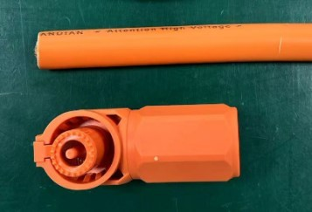 |  |  | 1. Prepare materials as shown | Use tin-plated cables
2 | 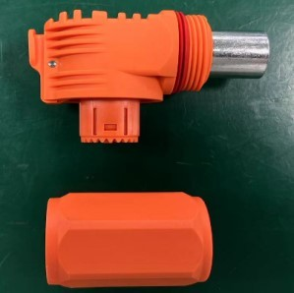 |  |  | 2. Remove plug nut back cover as shown
3 | 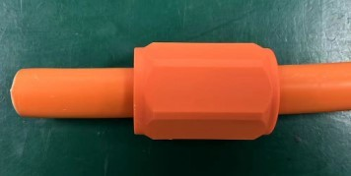 |  |  | 3.Thread the cable through the nut back cover assembly as shown
4 | 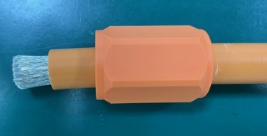 |  |  | 4. The insulation layer of the cable was peeled off 17.0±0.5 mm
5 | 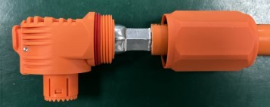 |  |  | As shown  1.Crimped terminals. The dimensions of the crimping refer to the requirements of this document. The crimping  should be held for 2 seconds
5 |  | Flatten the tail

6 | 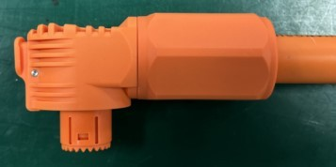 | Insert the nut back cover into the plug body, as shown, and the Assembly completed (1.0~ 1.2 N. M)

Step2: Instructions for matching plugs and sockets
2.1 The plug is aligned with the socket outlet 2.2 To insert, hear a click to indicate
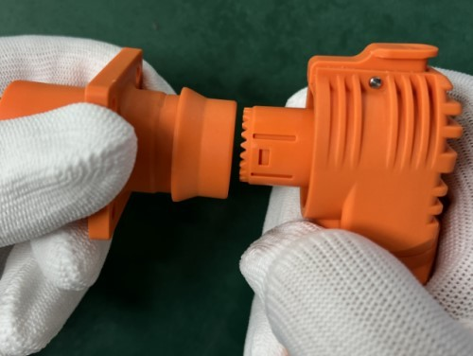
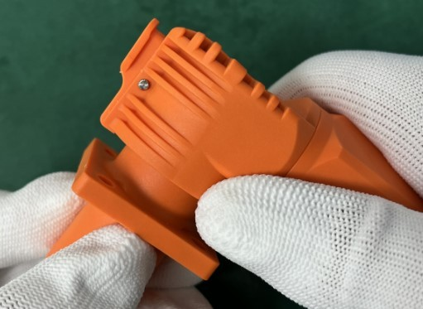
that the assembly in place
三. 拔出说明

Step 3 Disconnecting
3.1 Press the button down 3.2 Pull Up, you can pull out the plug
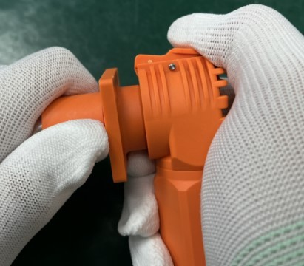
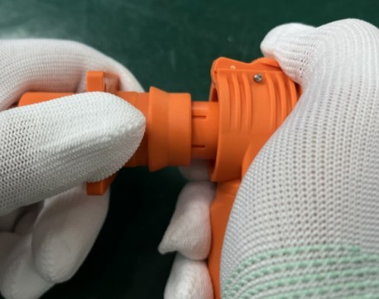
Press the button downwards
Step4: Recommended terminal riveting dimensions
Dimension of terminal riveting
2/0 AWG；70mm² | 3/0 AWG | 95mm² | 4/0 AWG | 120mm²
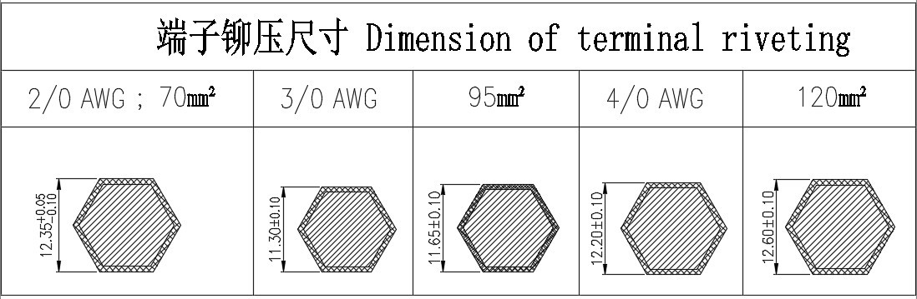

The above dimensions are for reference only and must meet the following holding force requirements:
Wire harness retention force after riveting: ≥2700N;
If the holding force is insufficient or the terminal is over-extended, please adjust the riveting size appropriately.

6.5.1.8 DC Power Supply Terminal Wiring
Step 1: Select a 4mm²cable (OD:2.7~3.7mm) and strip 5mm~10mm of the outer sheath from the cable port. First, install the foam to the plastic connector, and then pass the cable through the plastic connector.
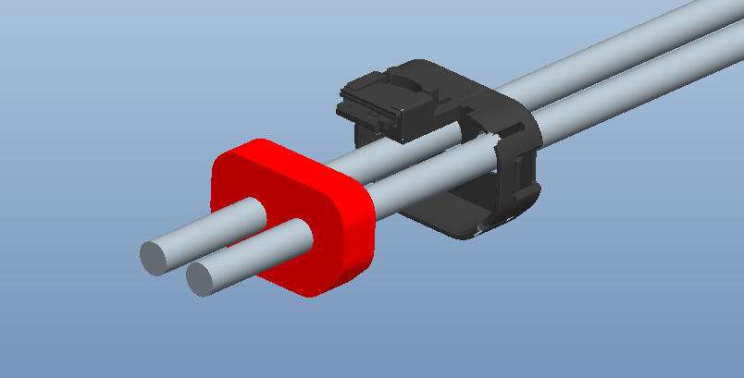
Step 2: Crimp the stripped end of the cable to the male connector terminal.
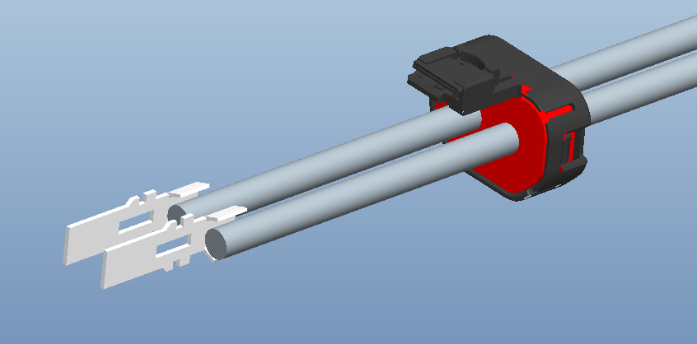
Step 3: After installation, as shown in the figure, insert the plastic connector with the crimped cable into the plug connector.
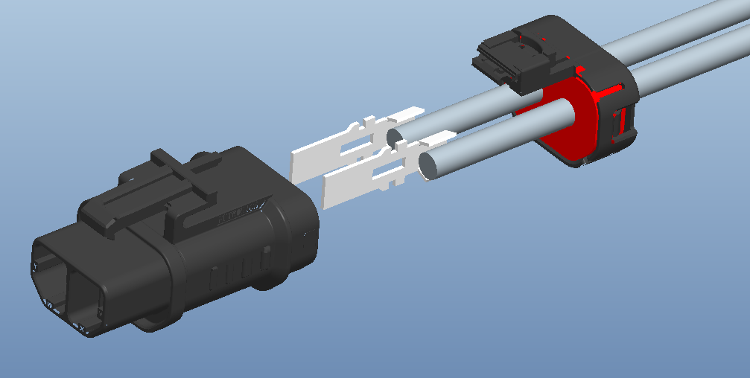
The complete schematic diagram is as follows:
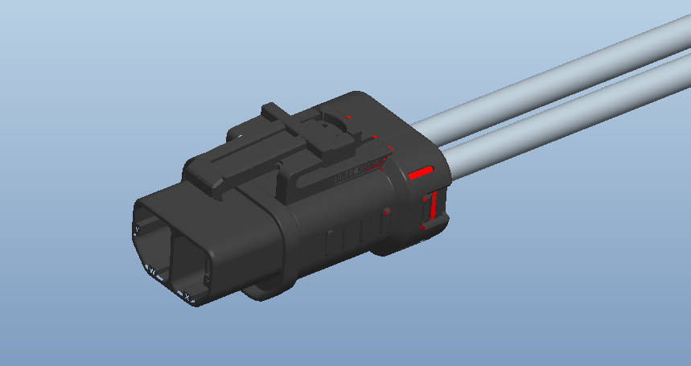

6.5.1.9 AC Power Supply Terminal Wiring
Step 1: Select a 4mm²cable (OD: 2.7~3.7mm) and strip 5mm~10mm of the outer sheath from the cable port. First, install the foam to the plastic connector, and then pass the cable through the plastic connector.
Step 2: Crimp the stripped end of the cable to the male connector terminal.
Step 3: After installation, as shown in the figure, insert the plastic connector with the crimped cable into the plug connector.
The complete schematic diagram is as follows:

6.5.1.10 Phoenix Terminal Wiring
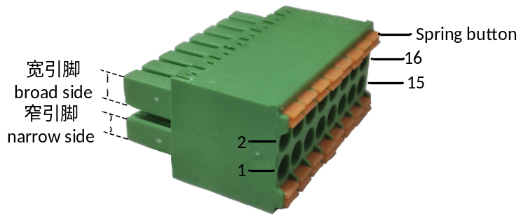
Figure 6.7 16Pin Phoenix Terminal Schematic
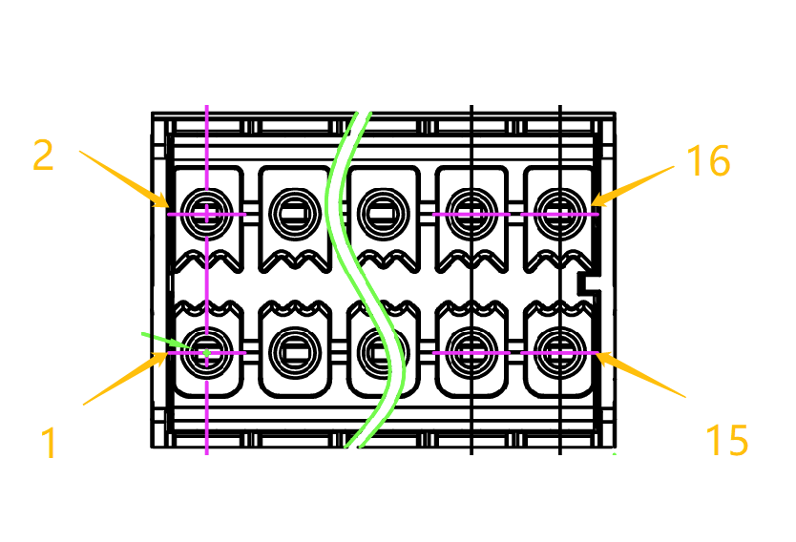
Figure 6.8 16Pin Phoenix Terminal Front View
Select cables with a cross-sectional area of 1.3mm² or 24~16AWG. Strip off 8±2mm of the outer sheath from the cable end. When wiring, you need to first press the spring button on the terminal with a small screwdriver, and then insert the cable into the corresponding wiring hole.
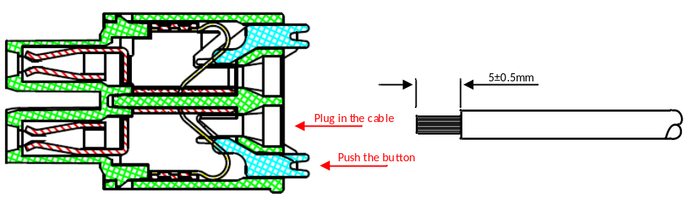
Figure 6.9 16Pin Phoenix Terminal Wiring Schematic

Select cables with a cross-sectional area of 1.3mm² or 16AWG. Strip off 8±2mm of the outer sheath from the cable end. When connecting the cable, lock the lower screw with a torque of ≤0.226Nm to fix the cable. After splicing with the base, tighten the corresponding front screw with a torque of ≤0.226Nm.
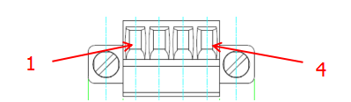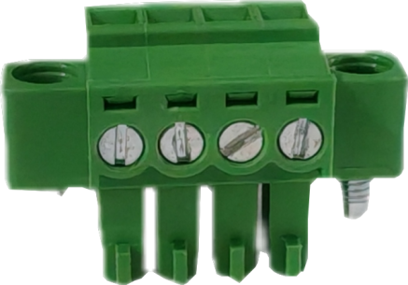

Figure 6.10 4Pin Phoenix Terminal Front Wiring
Diagram
Figure 6.11 4Pin Phoenix terminal's lower Wiring
Screw Diagram

6.5.1.11 Usage of Secondary Wiring Waterproof Terminals
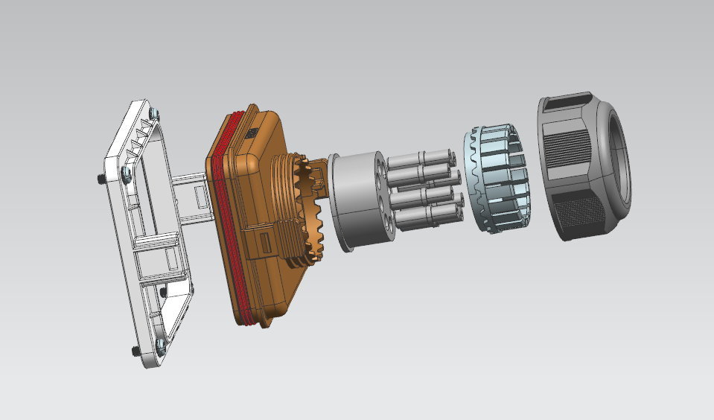
As shown in the above figure, from left to right are the base (with 1 piece of sealing ring and 4 pieces of screws), the main body (with 1 piece of sealing ring), the clamping ring, the waterproof plugs (8 pieces), the split claws, and the plastic nuts.

Usage steps:
1. Lock the base on the panel with screws.
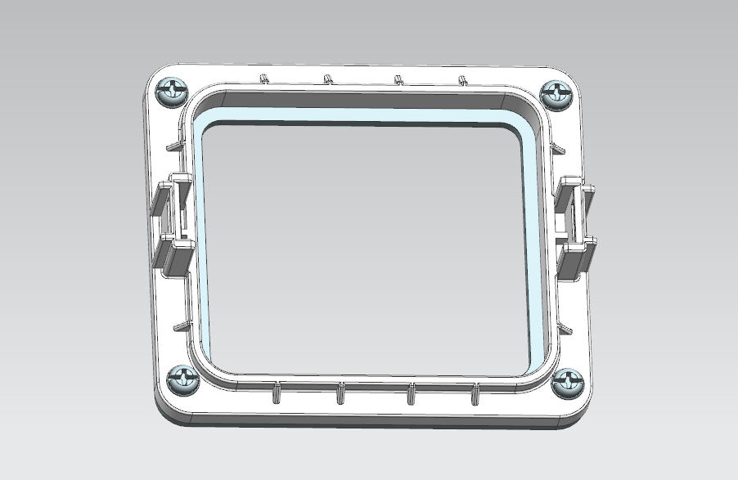

2. Remove the waterproof plugs from the round holes of the clamping ring as needed.
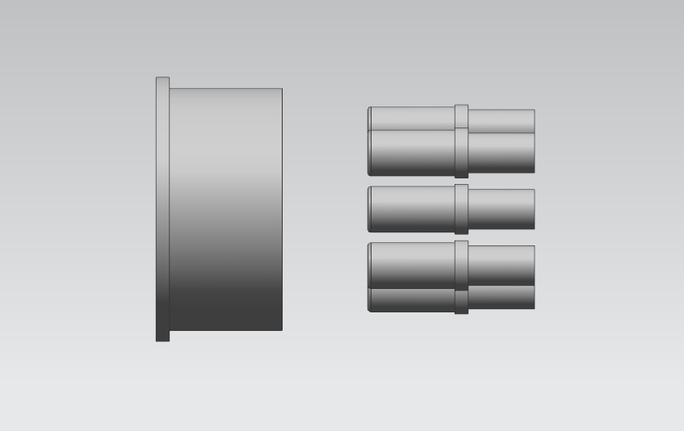
3.1 Pass the cable through the main body, clamping ring, split claws and plastic nut in sequence;
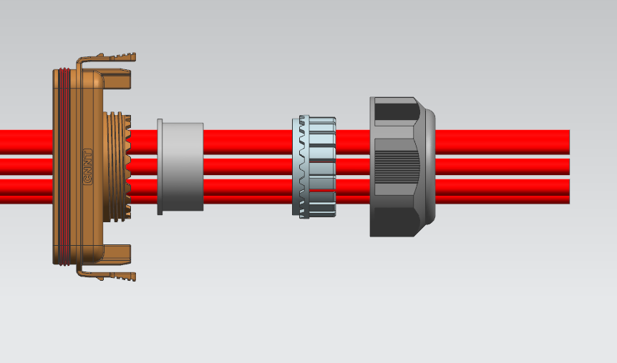
3.2 When the cable passes through the clamping ring, if both ends are crimped and cannot pass through the round hole, break open the cut of the clamping ring's round hole and insert the cable into the round hole of the clamping ring through the cut
.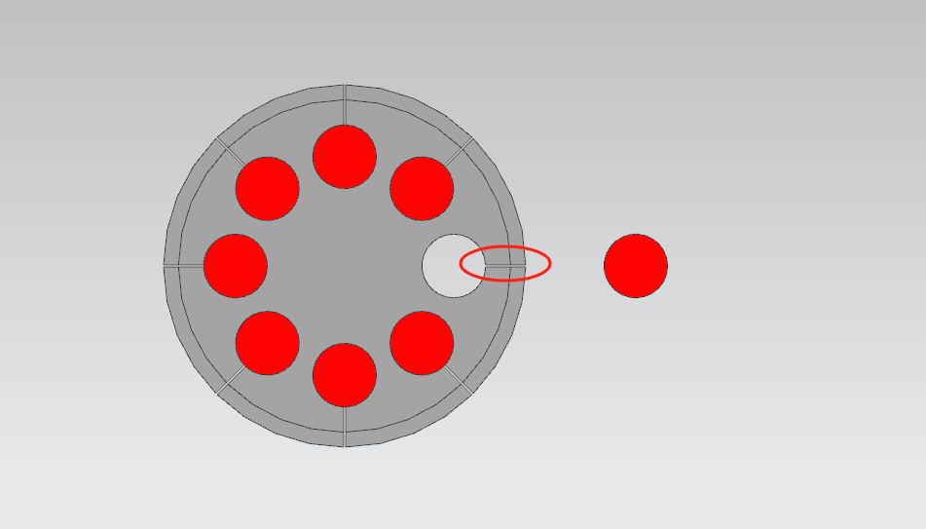
4. Fasten the main body onto the base, then fit the clamping ring into the slot of the main body, install the split claws, and finally tighten the plastic nut.
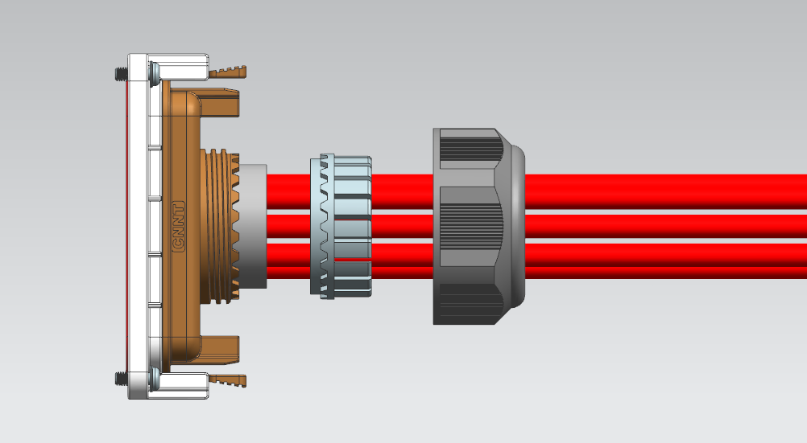
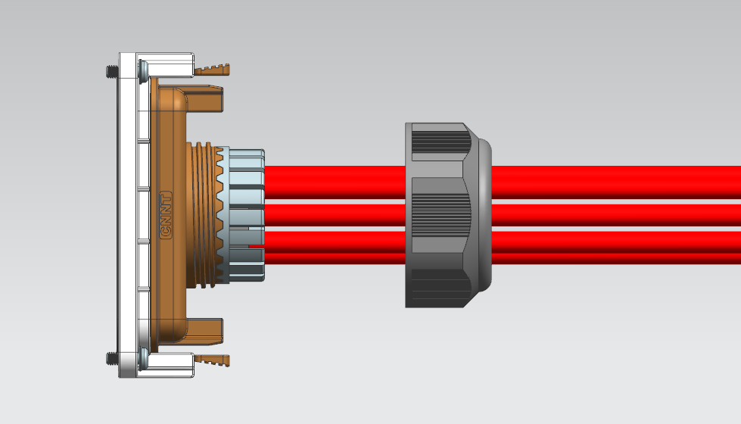
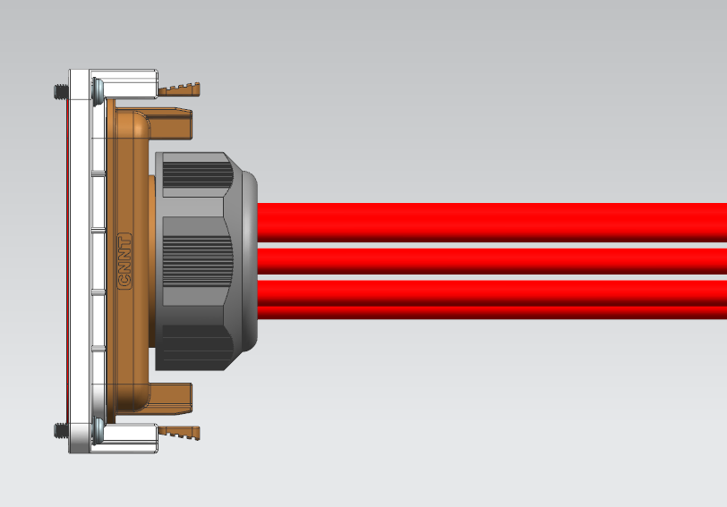

6.5.1.12 Secondary Terminal Wiring
In addition to the connection of power cables, the bi-directional storage inverter module also has connections to external communication signal lines, as well as the input and output of some node signals. The port definition of the secondary wiring is shown in the following figure:
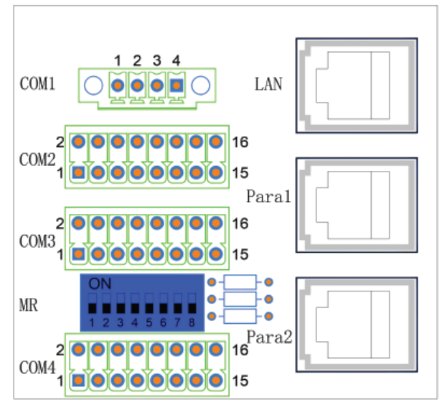
Figure 6.12 Wiring and Communication Interface Locations

Table 6-7 Communication Interface Description
Interface Location | PIN Definition | Description
COM1 | PIN1: DRY_OUTA  PIN2: DRY_OUTA_GND  PIN3: DRY_OUTB  PIN4: DRY_OUTB_GND | 1/2:Output Dry Contact A  3/4:Output Dry Contact B
COM2 | PIN1: GND  PIN2: +24V  PIN3: Reserved  PIN4: Reserved  PIN5: GND  PIN6: DRY_INC  PIN7: GND  PIN8: EPO_BMS  PIN9: SWITCH_OPEN_FB  PIN10: SWITCH_EN  PIN11: HALL_CANL  PIN12: HALL_CANH  PIN13: CAN_L  PIN14: CAN_H  PIN15: RS485B-1  PIN16: RS485A+1 | 1/2:24V Power Supply (20W)  3/4:Reserved  5/6:Input Dry Contact C  7/8:EPO_BMS (Open circuit fault)  9: Switch feedback signal (low level closed, high level disconnected; PCS output to BCMU)  10: Switch trip enable signal (low level enabled, high level disabled; BMS input to PCS)  Note: The common reference ground of PIN_9/10 is PIN_1 GND; To avoid affecting the lifespan of the isolation switch, except for serious faults on the DC side such as DC side short circuits, general faults should avoid forced tripping with current  11/12:Hall CAN Communication (BCMU Current Sampling Communication)  13/14:External CAN Communication（BMS Communication）  15/16:External RS485-1 Communication (Only supports connection to EMS or BMS.)
COM3 | PIN1: /  PIN2: /  PIN3: /  PIN4: /  PIN5: /  PIN6: /  PIN7: /  PIN8: /  PIN9: Dry_INA _GND  PIN10: Dry_INA  PIN11: Dry_INB _GND  PIN12: Dry_INB  PIN13: EPO_GND  PIN14: EPO  PIN15: RS485B-2  PIN16: RS485A+2 | 1/2:Reserved  3/4:Reserved  5/6:Reserved  7/8:Reserved  9/10:Input Dry Contact A  11/12:Input Dry Contact B (DRM0)  13/14:EPO (Open circuit fault)  15/16:External Options RS485-2 Communication (Sinexcel PDS1-60k, insulation tester, meter)
COM4 | Reserve Communication | Reserve Communication
MR | DIP Switch 1  DIP Switch 2  DIP Switch 3  DIP Switch 4  DIP Switch 5  DIP Switch 6  DIP Switch 7  DIP Switch 8 | Module IP Reset  RS485-2 Matching Resistance  Hall CAN Matching Resistance  External CAN Matching Resistance  External RS485-1 Matching Resistance  CANC Matching Resistance  CANB Matching Resistance  CANA Matching Resistance
LAN  （RJ45） | LAN | Ethernet Communication Port
Para1  （RJ45） | PIN1: CANA_H  PIN2: CANA_L  PIN3: CANB_H  PIN4: Carrier_Sync_BUS_ISO  PIN5: GND_ISO  PIN6: CANB_L  PIN7: 50Hz_Sync_BUS_ISO  PIN8: GND_ISO | 1/2:Synchronized CANA；  3/6:Synchronized CANB；  4/5:Synchronized bus 1；  7/8:Synchronized bus 2；
Para2  （RJ45） | PIN1: CANA_H  PIN2: CANA_L  PIN3: CANB_H  PIN4: Carrier_Sync_BUS_ISO  PIN5: GND_ISO  PIN6: CANB_L  PIN7: 50Hz_Sync_BUS_ISO  PIN8: GND_ISO | 1/2:Synchronized CANA；  3/6:Synchronized CANB；  4/5:Synchronized bus 1；  7/8:Synchronized bus 2；
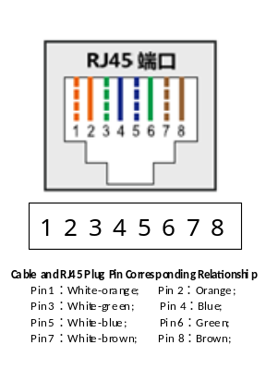
Figure 6.13 Schematic Diagram of RJ45 Interface Wiring Sequence

Table 6-8 Summary of Input and Output Dry Contact Information
Dry Contact Name | EPO | EPO_BMS | Input Dry Contact A | Input Dry Contact B | Input Dry Contact C | Output Dry Contact A | Output Dry Contact B
Dry Contact Function | Default EPO Open Circuit Fault | Default BMS Open Circuit Fault | EPO Redundant Fault Dry Contact | DRM0 | BMS Redundant Fault Dry Contact | PCS Status Output Dry Contact | PCS Status Output Dry Contact
Can be Disabled | NO | NO | YES | YES | YES | YES | YES
Optional Function 1 | / | / | EPO Open Circuit Fault | / | BMS Open Circuit Fault | PCS Start/  Stop | PCS Fault/  Normal
Optional Function2 | / | / | EPO Short Circuit Fault | / | BMS Short Circuit Fault | PCS  Off-grid /Grid-  connected | Electrical Fan Start/  Stop

If it is necessary to use the output dry contact to drive load devices such as indicator lights and external fans, it is necessary to communicate with our company's technical personnel to determine the solution and its application.
The output dry contact is of the relay on-off type with electrical parameters of 24V 2A. Caution: Do not directly use it for switching circuits where surge current may occur.

6.5.1.13 Selection of Fuses and Switching Devices
PWS1-135M is equipped with fuses and disconnectors on the DC side, no fuses or circuit breakers on the AC side. It is necessary to configure corresponding switching devices, and the device selection is as follows:

AC Circuit Breaker:
It is recommended to select a four-pole plastic-cased AC circuit breaker with synchronized breaking on the N line;
The rated voltage Ue is recommended to be 500V;
Note: The rated voltage Ue is recommended to be 600V when the grid voltage is unstable;
The rated current In is recommended to be 250A*N; N represents the number of parallel connections on the AC side of the PCS;
Remarks: When the altitude is higher than 1000m or the temperature is higher than 40℃, it will be considered with the actual working condition and circuit breaker brand for derating. after derating, it must still meet the rated current requirement;
The rated ultimate short-circuit sectionalization capacity Icu is based on the AC side transformer parameters after calculation;
The rated operating short-circuit sectionalization capacity Ics is calculated from the AC side transformer parameters;
The matching cable should be selected as 70mm².

If grid-connected and off-grid switching is required, an N-PE contactor can be externally with added to connect the N line:
Rated voltage (Ue): Recommended 1500 VDC or 500 VAC and above
Rated current (In): Recommended 600 A (For use with four sets of 135M modules or less connected in parallel);
Note: When the altitude is higher than 1000m or the temperature is higher than 40℃, it will be considered with the actual working condition and brand for derating.
The short-time withstand capability shall bear the current energy of 2.24kA/436ms caused by the three-phase-to-N short circuit in off-grid mode (test data of four sets of 135M modules connected in parallel).

PWS1-135M-R is not equipped with fuses and fusion switches or circuit breakers on the DC side, no fuses or circuit breakers on the AC side. It is necessary to configure corresponding switching devices, and the device selection is as follows:

AC Circuit Breaker:
It is recommended to select a four-pole plastic-cased AC circuit breaker with synchronized breaking on the N line;
The rated voltage Ue is recommended to be 500V;
Note: The rated voltage Ue is recommended to be 600V when the grid voltage is unstable;
The rated current In is recommended to be 250A*N; N represents the number of parallel connections on the AC side of the PCS;
Remarks: When the altitude is higher than 1000m or the temperature is higher than 40℃, it will be considered with the actual working condition and circuit breaker brand for derating. after derating, it must still meet the rated current requirement;
The rated ultimate short-circuit sectionalization capacity Icu is based on the AC side transformer parameters after calculation;
The rated operating short-circuit sectionalization capacity Ics is calculated from the AC side transformer parameters;

DC Circuit Breaker or DC Disconnector:
The rated voltage Ue is recommended to be 1500V;
The rated current In is recommended to be 250A*N; N represents the number of parallel connections on the DC side of the PCS;
Remarks: When the altitude is higher than 1000m or the temperature is higher than 40℃, it will be considered with the actual working condition and circuit breaker brand for derating,after derating, it must still meet the rated current requirement;
The breaking capacity shall be selected according to the maximum short-circuit current of the battery system.

DC Fuse:
The rated voltage Ue is recommended to be 1500V;
The rated current In is recommended to be 400A*N; N represents the number of parallel connections on the DC side of the PCS;
Remarks: When the altitude is higher than 1000m or the temperature is higher than 40℃, it will be considered with the actual working condition and circuit breaker brand for derating,. after derating, it must still meet the rated current requirement;
The breaking capacity shall be selected according to the maximum short-circuit current of the battery system.

If grid-connected and off-grid switching is required, an N-PE contactor can be externally with added to connect the N line:
Rated voltage (Ue): Recommended 1500 VDC or 500 VAC and above
Rated current (In): Recommended 600 A (For use with four sets of 135M modules or less connected in parallel);
Note: When the altitude is higher than 1000m or the temperature is higher than 40℃, it will be considered with the actual working condition and brand for derating.
The short-time withstand capability shall bear the current energy of 2.24kA/436ms caused by the three-phase-to-N short circuit in off-grid mode (test data of four sets of 135M modules connected in parallel).

6.5.2 Communication Interface Connection
The bi-directional storage inverter supports the Modbus protocol and adopts RS485 and Ethernet communication interfaces, which facilitates users to conduct background monitoring, enabling remote signaling, remote regulation, remote measurement, and remote control of the bi-directional energy storage inverter. The energy storage inverters of Sinexcel have several different communication interfaces: Ethernet, RS485, and CAN.

The PCS has only one set of RS485, CAN, and Ethernet respectively. For example, if the RS485 interface is connected to the EMS, the BMS that uses RS485 communication cannot be connected.
Table 6-9 Communication Interfaces with Other Devices
Equipment | Wiring method
EMS | RS485 or Ethernet  (protocol based on MODBUS TCP/IP，compatible with MODBUS RTU)
BMS | RS485 (protocol based on MODBUS RTU) or CAN(CAN2.0 protocol specification)
Other PCS | CAN
PMS-U2-P Control Box | CAN, Ethernet
Exchanger | Ethernet
Photovoltaic Inverter | Through external EMS
Intelligent Electricity Meter | Through external EMS
Air Conditioner | Through external EMS
Fire Protection System | Through external EMS
Level Tool | Through external EMS
Diesel Generator | Through external EMS

6.5.2.1 Connect to EMS via RS485 or Ethernet
EMS can be connected via RS485 or Ethernet, depending on the specific application of the user.
RS485 Serial Port
The signal pins of the RS485 communication interface on the bi-directional storage inverter monitoring board are PIN16(A) and PIN15(B) of COM2. Users can use an interface inverter to convert the serial port signal into a signal that can be processed by a PC (such as RS485 to RS232), and use the user software system to perform individual debugging on the bi-directional storage inverter, read the operation information and alarm information of the bi-directional storage inverter, and perform corresponding settings, power-on/off operations, etc. Please refer to Figure 6.12.
Ethernet Port
Meanwhile, the monitoring board is equipped with an Ethernet interface, labeled as LAN, which supports the Modbus TCP/IP protocol and has its own IP address. For Ethernet connection of multiple modules, a switch is required, and a fixed IP needs to be set. The connection cable is a network cable or twisted pair cable. Connect the network ports of multiple bi-directional storage inverter to the switch, and connect the switch to the remote monitoring computer. Set the corresponding IP address and port number in the monitoring computer to realize real time monitoring and control of the status of the bi-directional storage inverter. Please refer to Figure 6.12.

6.5.2.2 Connect to BMS via RS485 or CAN
When the bi-directional storage inverter communicates with the BMS system, RS485 or CAN communication can be used. If the BMS uses an Ethernet communication port, an Ethernet-CAN protocol inverter is required. The Ethernet-CAN protocol inverter is beyond the supply scope of Sinexcel and must be purchased separately by the customer. The bi-directional energy storage inverter communicates with the battery management unit (BMS), monitors the battery status information, issues alarms based on the battery status, and provides fault protection for the battery to improve battery safety. The signal pins of the CAN communication interface are PIN14(H) and PIN13(L) of COM2. Please refer to Figure 6.12. The CAN Hall wiring requires that the 24V power signal ground of the BMS be connected to the 24V signal ground of the PCS, with the wiring length as short as possible and the grounding impedance minimized.

6.5.2.3 Fault Dry Contact with BMS
Fault dry contact communication between the bi-directional storage inverter and the BMS system. PIN8 and PIN7 of COM2 can access the total BMS fault dry contacts. This is configured as an open circuit fault : the BMS input fault dry contacts are normally closed under normal conditions. When a BMS fault occurs, a disconnection signal is sent to the PCS, and the PCS will report a fault and stop operation. Please refer to Figure 6.12.

6.5.2.4 Switch Status Feedback and Trip Feedback Signals
The bidirectional energy storage inverter generates backup signals for "switch status feedback" and "trip enable" to interact with the BMS, which are achieved through PIN9 and PIN10 of COM2. The reference ground for the on status feedback and trip enable signals is PIN1 GND of COM2, as shown in Figure 6.6.
The switch status feedback indicates that the low level is closed and the high level is open; Output from PCS to BCMU.
When the switch trip signal is high, it means it is not enabled, and when it is low, it means it is enabled to trip; Output from BCMU to PCS.
.Important Note: To extend the service life of the system, the disconnector shall not be opened under current load for non-critical DC-side faults (e.g., current-uncontrollable faults such as DC-side short circuit). Therefore, when the BMS needs to actively control the tripping of the isolation switch, it must first issue a shutdown command or a zero-current-limiting command, followed by the isolation switch tripping command.

6.6 Installation Checklist
After the bi-directional storage inverter is installed, it needs to be checked:
1) The equipment should be placed and installed reasonably to meet the safety distance requirements.
2) The wiring is correct. The ground wire is well connected to the ground grid. Ask the technician to check the ground resistance.
3) Compare the factory main wiring diagram with the on-site wiring diagram. Check if there are any differences and determine whether they will affect the safe operation of the energy storage system. After installation, check the following list:
Table 6-10 Installation Checklist
Mechanical Installation Inspection | √
There is enough free space in front and behind the Bi-directional storage inverter to meet maintenance requirements. | □
The environmental operating conditions are within the specifications. | □
The Bi-directional storage inverter is correctly installed and fixed. | □
Make sure nothing blocks the heat dissipation duct of the energy storage inverter to ensure air circulation and meet the heat dissipation requirements. | □
Electrical Installation Inspection | √
The Bi-directional storage inverter (including cables) is grounded correctly. | □
The AC line voltage matches the rated output voltage of the Bi-directional storage inverter. | □
The parameters of the external medium-voltage or low-voltage AC transformer match those of the Bi-directional storage inverter. | □
Ensure that the insulation of the cables is good and meets the specifications. | □
The terminals of the AC power supply L1, L2, L3, and N are connected with the travel in place and the cable fastened. | □
The DC power supply cables are connected to the terminals of DC+ and DC- with the travel in place and the cables fastened. | □
Auxiliary cables and control cables must be routed separately from power cables. | □
The external control cable is correctly connected to the port of the Bi-directional storage inverter. | □
The cable connections and tightening torque on the junction box are appropriate. | □
External cable insulation withstand voltage test. | □
The grounding resistance should be less than 4Ω. | □
7 Operation and Debugging

7.1 Control Method

7.1.1 Ethernet Connection
Use Ethernet connection. First, open the browser on the computer desktop(Google Chrome recommended), then enter the default IP of the machine (192.168.1.10) in the URL bar of the browser, and the login interface shown in Figure 7.1 will appear.
Enter “admin” in the Name input box.
Enter the initial password "123456" in the Password input box.
Click “Log in” to enter the background operation interface of PWS1-135M, as shown in Figure 7.2.
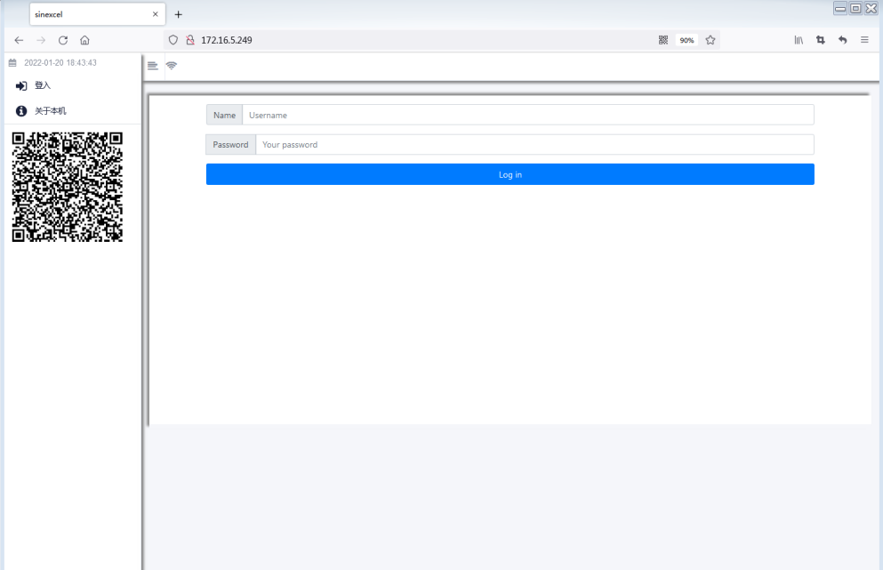
Figure 7.1 Login Interface

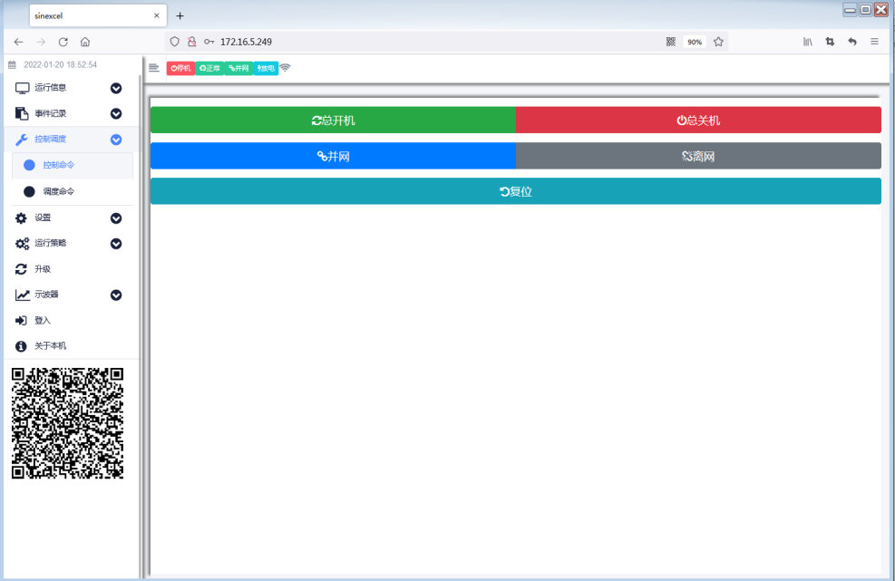
Figure 7.2 Example of web backend operation interface

7.1.2 RS485 Connection
Use RS485 connection (For communication between PCS and EMS or BMS). Before using RS485 connection, please follow the previous two methods on the computer, mobile phone or other devices;
Logging in to the device, select RS485-1 in " Monitoring Settings" in the " Settings " tab to connect to the BMS or BMS, as shown in the figure below.
Connection to BMS requires only setting the baud rate. It is recommended that the BMS timeout be set to 5 seconds (Note: The value must not be set to 0; setting to 0 will disable the detection of communication loss). Other settings are generally unnecessary.
Connection to EMS requires only setting the baud rate. It is recommended that the RTU timeout be set to 5 seconds. Other settings are generally unnecessary.
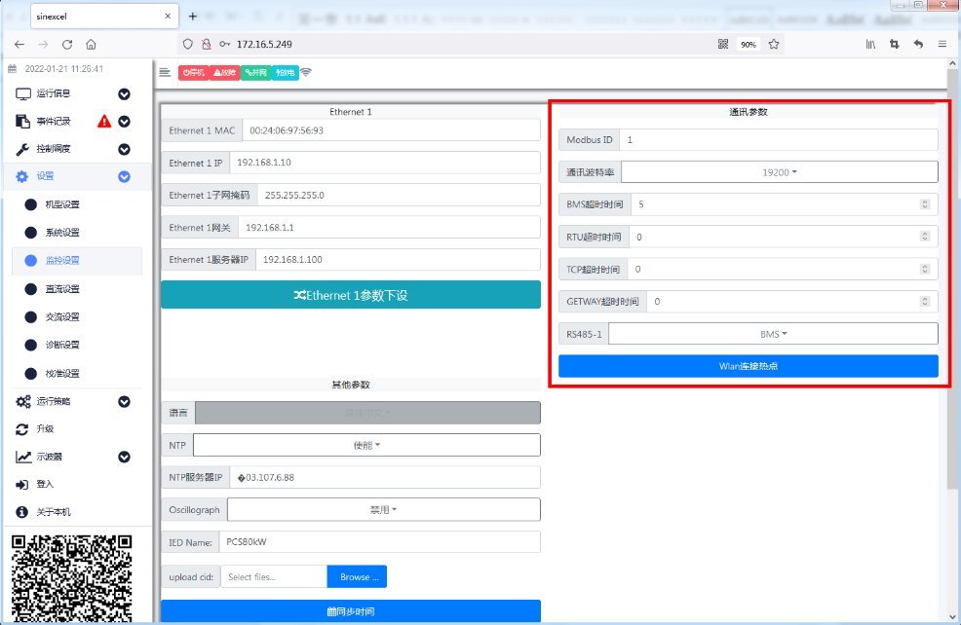
Figure 7.3 RS485 Connection Settings

7.2 Power-on and Power-off
After the energy storage device has been installed and debugged normally by engineers and the external power switch has been closed, power-on procedure can be carried out.

7.2.1 Check before Starting
Before starting up, check the equipment according to the following steps:
- Visually check that there is no sign of damage on the outside of the module, and confirm that the external DC circuit breaker and AC circuit breaker are both in the "OFF" state;
- According to the inspection items after installation in Section 6.6. The DC disconnector may be switched on in padlock mode during the inspection, as shown in the figure below. Check whether the DC input wiring and AC output wiring of the energy storage device are normal and whether the grounding is good;
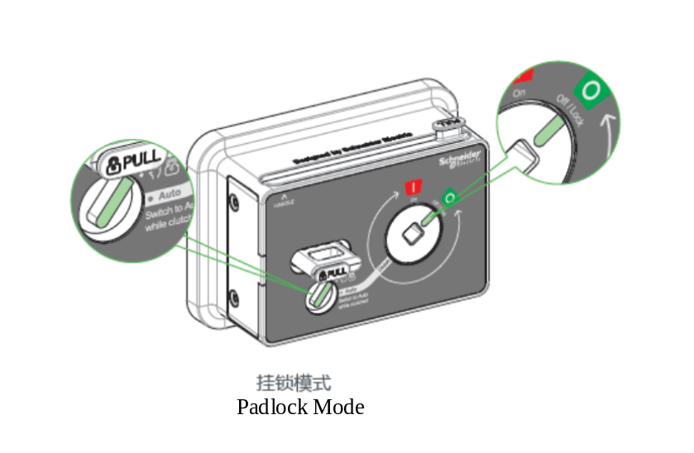
- Check whether the battery voltage is normal;
- Check whether the phase voltage and line voltage on the grid side are within the normal range, and record the voltage values.

7.2.2 Power-on Steps
- Rotate the handle clockwise to close the module DC disconnector to the "ON" state, as shown in the following figure(Before using the extension handle, it is necessary to confirm the position of the knob at the red box in the following figure. Only when the knob points to the position of the "palm" icon can the extension handle be used to rotate the main switch operation.):
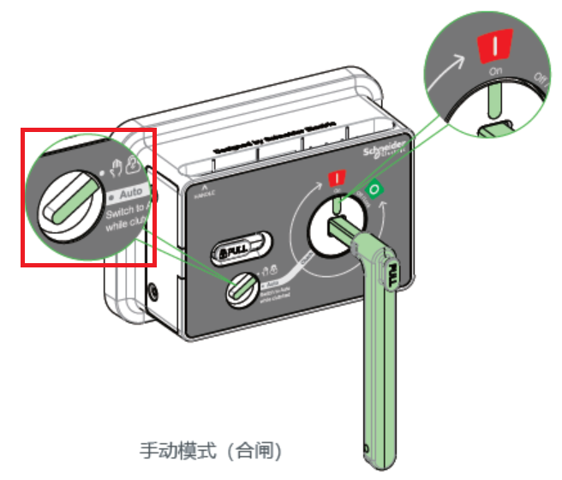
Manual Mode (Close)
- Close the output circuit breaker of the battery cabinet, power on the DC port of the equipment, and you will see the power indicator light on the panel illuminated. After waiting for the buzzer prompt, rotate the DC isolation switch status prompt line counterclockwise to the mode switching position (Clutch), then use the tail of the handle to turn the small knob on the switch panel to Auto mode, and place the handle back into the groove above the switch (* if the knob points to the "Auto" position, do not use the extension handle to rotate the main switch operation), as shown in the following figure:
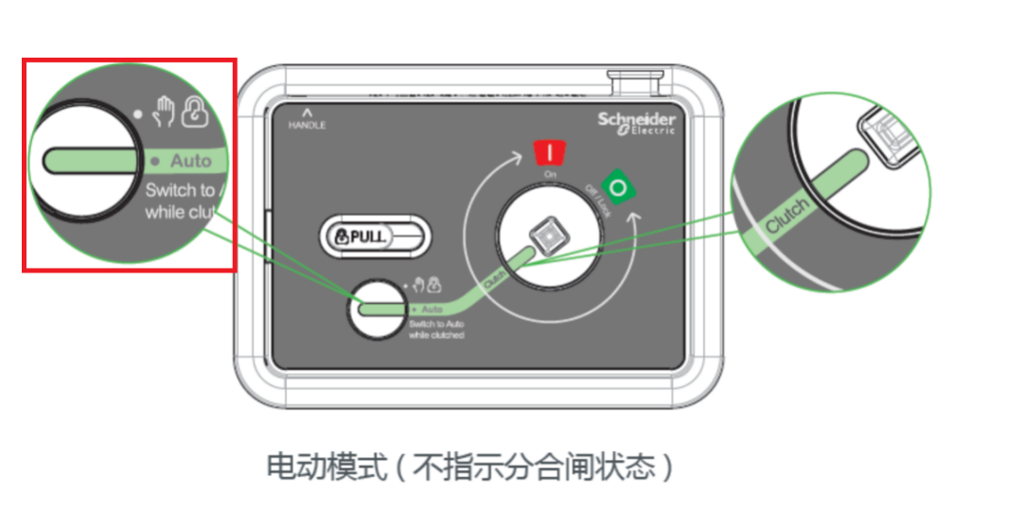
Electric mode (does not indicate on/off status)
- First, open the browser on the computer desktop (Google Chrome is recommended), then enter the machine 's default IP (192.168.1.10) in the browser 's URL bar, and the login interface shown in Figure 7.1 will appear.
Enter “admin” in the Name input box.
Enter the initial password "123456" in the Password input box.
Click “Log in” to enter the background operation interface of PWS1-135M, as shown in Figure 7.1.
At this time, the "Current Alarm " in the " Event Record " will display information such as "AC #01 AC bus undervoltage", "AC #01 AC bus underfrequency ", etc.
When the device is started for the first time, it is necessary to set the battery DC protection parameters and communication configuration.
- The inverter works in grid-connected mode by default. Close the external AC circuit breaker and power on the AC port of the machine. At this time, the information such as "AC #01 AC bus undervoltage" and "AC #01 AC bus underfrequency " displayed in "Current Alarm " will be automatically eliminated.
- Click the "Control Scheduling " tab on the left side of the webpage, and set the start-up command in the "Control Command" so that the inverter starts to connect to the grid.
- If the inverter needs to operate in off-grid mode, please re - issue the command after step (2) and set the working mode to off-grid mode. After the setting is successful, the information such as "AC #01 AC bus undervoltage" and "AC #01 AC bus underfrequency" displayed in the "Current Alarms" will be automatically cleared. After issuing the power-on command, check whether the voltage of the AC bus in the "Operating Information" on the web page is the voltage level in the model settings.After confirming that there are no errors, close the external switch to supply power to the load.

7.2.3 Power-off Steps
- Click the "Control Scheduling " tab on the left side of the webpage, and set the shutdown command under "Control Command";
- Check whether the inverter is in shutdown state;
- Disconnect the AC circuit breaker;
- Disconnect the DC circuit breaker.
- Open the DC disconnector on the module panel, rotate it counterclockwise to the "OFF" state, as shown in the following figure, and place the handle back into the slot.
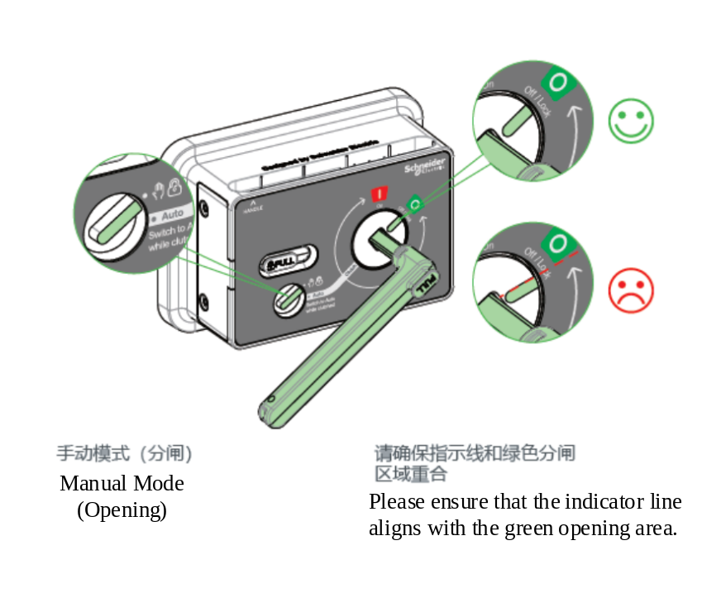
*Note: Precaution on the use of the switch extension handle
The isolation switch should be used according to the requirements during use, and incorrect use can cause switch failure!

Do not quickly hand operate the switch; The speed limit for manually rotating the handle is 40r/min. If the operating speed is too fast, it will generate severe mechanical impact, causing permanent damage to the switch and failure of opening and closing.

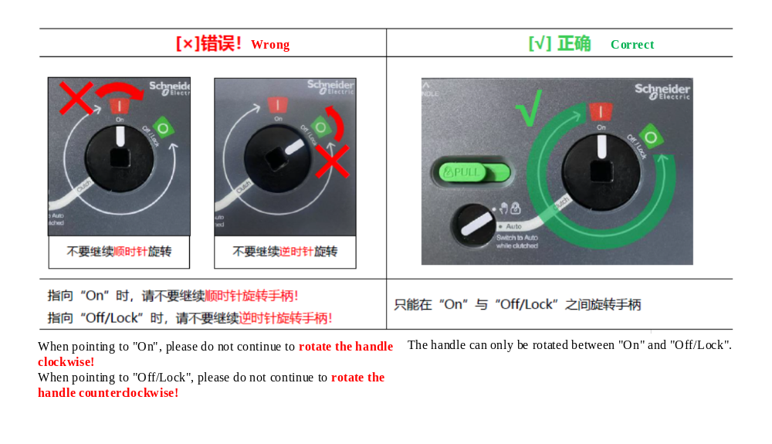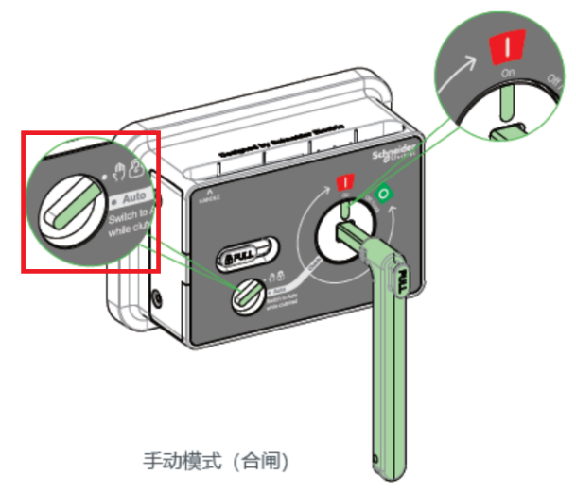 | 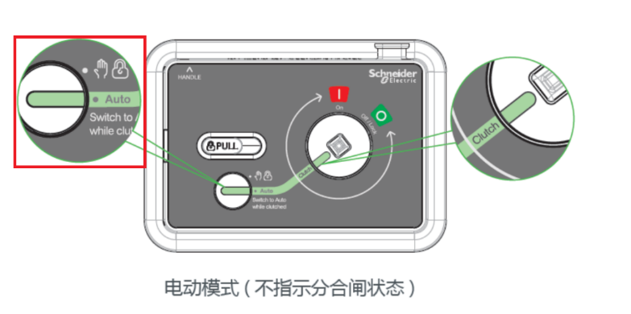
Only when the knob points to the position of the "palm" icon, can the extension handle be used to rotate the main switch operation | If the knob points to the "Auto" position, the extension handle cannot be used to rotate the main switch operation

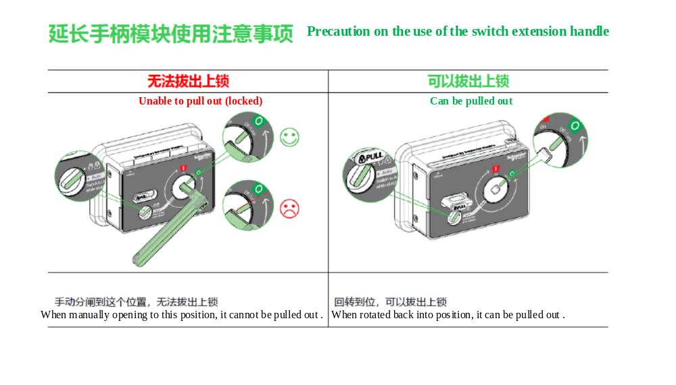

8 Troubleshooting

8.1 Safety Precautions
There may be a risk of electric shock due to high voltage. The built-in ground fault detection function can detect insulation faults and trigger protection actions to reduce electric shock risks.
Under fault conditions, the product may be under high voltage. Touching the live parts of the equipment may lead to danger or death.
Severe injury may occur due to electric shock.
When operating the product, please follow all safety information.
When performing product maintenance, appropriate personal protective equipment must be worn.
If you still cannot solve the problem through this document, please contact the manufacturer.

8.2 Exporting Equipment Operation Data
When it is necessary to send the logs to the manufacturer for analysis, the equipment operation records need to be downloaded.
1.Log in to the web based control interface using a password.
2.Select "Event Records" > "Download Records" > "Download All Records". After the download is complete, you can save the record file in the browser.

8.3 Common Faults
The following table shows the faults caused by incorrect parameter settings.
Users can reset the parameters according to the instructions in the appendix, and then the faults can be automatically resolved.


Alarm classification:
Fault :Shutdown;
Warning :Warning but not shutdown.

Alarm clearing method:
Auto: the alarm is automatically cleared after the alarm cause disappears;
Manual: After the alarm cause disappears, the alarm is cleared by sending a reset command;
Power off : After the alarm cause disappears, the alarm is cleared by powering off and restarting

Alarm classification:+clearing method(Abbreviated as A.C. (Automatic Alarm Clearance) + C.M. (Manual Clearance))
Fault + Automatic FA
Fault + Manual FM
Fault + Power off FP
Warning + Automatic WA
Warning + Power off WP

Table 8-1 Common Faults
Fault type | A.C.+C.M | Cause
AC bus overvoltage | A.C. | AC voltage higher than overvoltage protection setting
AC bus undervoltage | A.C. | AC voltage lower than undervoltage protection setting
AC bus overfrequency | A.C. | AC frequency higher than overfrequency protection setting
AC bus underfrequency | A.C. | AC frequency lower than underfrequency protection setting
AC Bus Reverse Phase | A.C. | Reverse phase of AC bus connection
AC Bus Missing Neutral (N) | A.C. | Missing N-line in AC connection
DC Input Reverse Connection | A.C. | Reverse connection of DC incoming line
DC Input Overvoltage | A.C. | Current DC voltage of the device is higher than the upper limit of DC voltage
DC Input Undervoltage | A.C. | Current DC voltage of the device is lower than the lower limit of DC voltage or DC voltage is not connected
DC Bus Overvoltage | A.C. | Voltage on the DC bus capacitor is too high during module operation
DC Bus Undervoltage | A.C. | Voltage on the DC bus capacitor is too low during module operation
Low Battery Energy | A.C. | 1. Receiving a battery discharge - end signal from BMS in off-grid state;  2. In off-grid state, DC voltage is lower than the discharge end voltage
Parameter Mismatch | A.C. | 1. <DC parameters> are not set reasonably;  2. AC incoming line is not three-phase four-wire system
Emergency Shutdown | C.M. | EPO signal open circuit at the secondary terminal of the panel
Frequent Start-stop | C.M. | Frequent start-stop within 15 minutes
Insulation Abnormality 1 | C.M. | There is a large leakage current, and related equipment has a leakage problem
DC Insulation Detection Abnormality | A.C. | Insulation resistance between DC and ground of the inverter is less than the set value or lower limit
Module Overtemperature 1 | A.C. | Switch tube overtemperature, air duct may be blocked
Ambient Overtemperature Fault | A.C. | Ambient temperature is too high, and ambient ventilation and heat dissipation may be abnormal

8.4 Detailed Troubleshooting
For detailed troubleshooting, please consult our technical staff.

9 Maintenance

9.1 Safety during maintenance

High voltage exists in the live parts of the product. Touching live parts may cause death or serious electric shock damage.
When performing maintenance, wear appropriate personal protective equipment.
Do not touch any live parts.
Review all warning messages in the product and documentation.
Please follow all safety information provided by the battery manufacturer.
Before performing any work, be sure to disconnect the external power supply from the Bi-directional storage inverter:
- Grid voltage for grid feed
- Internal power supply
- DC voltage of the battery
- Additional external voltage, e.g. control signals from the control room
Make sure that disconnected devices cannot automatically reconnect.
After switching off the device, wait at least 5 minutes before switching it on again to allow the capacitors to discharge completely.
Before operation, make sure that all components are completely free of voltage.
Cover or insulate any adjacent live components.

Prevent product damage caused by dust intrusion and moisture penetration
The ingress of dust or moisture can damage the product and impair its functionality.
Only perform maintenance work in a dry and dust-free environment.
Product maintenance is only allowed when the product is turned off.
Reconnect external power after installing the product.
If the installation or commissioning process is interrupted, install all bezels. Close and lock the chassis.
Store the product in a dry area.

9.2 Maintenance Plan and Spare Parts

9.2.1 Operating Environment Requirements
The environment in which the equipment is installed must meet the operating environment requirements of the equipment:
Allowable ambient temperature: -40~60℃
Allowable relative humidity:：0~100％(non-condensing)(Prototype)
Maximum permitted altitude:3,000m
Note: When the maximum height is exceeded, the PCS will have its output derated.
For specific derating factors, please consult our technical staff.

9.2.2 Electrical and Fixed Connection Inspection
After putting into operation, conduct regular inspections on the connections of the electrical and fixed components of the equipment. It is recommended to check once every three months. The following items should be checked each time:
- Ground connection;
- Module ground connection.
- Electrical connections for DC input;
- Electrical connections for AC input;
- Connection of communication and control cables
- Fan and heat dissipation air ducts;
- Access the fault information recorded by the monitoring system.

9.2.3 Clearing and Cleaning
Before the equipment is put into operation, its radiator, terminals and mesh should be cleaned of dust and debris.
After the equipment is put into operation, the dust in the machine room should be cleaned regularly. Check whether the ventilation and exhaust facilities in the equipment room are normal. It is recommended to clean it every three months.

9.3 Maintenance Work
- In severe environmental conditions the maintenance intervals should be shortened.
- Site location and environmental conditions will affect maintenance intervals. Pay attention to cleaning and corrosion prevention.
- More frequent maintenance may be required, depending on site conditions.
- If the DC distribution components are subject to harsh environmental conditions, shorter maintenance intervals are recommended.
- We recommend regular visual inspections to determine if maintenance is required.

Consumables and maintenance materials
Consumables and maintenance materials are not usually included in the standard equipment list;
Only professionals or electrically qualified personnel can perform the operation;

Live maintenance work;
View history;
Read error messages and warnings;
Check the fan;

Maintenance without power supply;
View history;
Conduct a visual inspection;
Check the connections of the power cables;
Check the label;

10 Appendix

10.1 Quality Assurance
applies to the following existing product models:
• PWS1-135M-EX
• PWS1-135M-EX-R
• PWS1-125M-EX
• PWS1-125M-EX-R
•PWS1-100M-EX
•PWS1-100M-EX-R

If a product fails during the warranty period, Shenzhen Sinexcel Electric Co., Ltd. (hereinafter referred to as the Company) will repair or replace it with a new product free of charge.
- Evidence
During the warranty period, our company requires customers to present the invoice and date of purchase of the product. At the same time, the trademark on the product should be clearly visible, otherwise we have the right to not provide quality assurance.
- Condition
The replaced defective products will be handled by our company.
Customers should allow the Company reasonable time to repair faulty products.
- Waiver of liability
In the following circumstances, our company has the right not to provide quality assurance:
- The whole machine and its components have exceeded the free warranty period.
- Shipping damage.
- Improper installation, modification or use.
- Operation in very severe environments beyond those specified in this manual.
- Equipment failure or damage caused by installation, repair, modification or disassembly by anyone other than our company’s service personnel.
- Equipment failure or damage caused by the use of non-standard or non-Sinexcel parts or software.
- Any installation and use beyond the scope specified in the relevant international standards.
- Damage caused by abnormal natural environment.
If the product fails due to the above situation and the customer requires repair service, the paid repair service may be discontinued after the judgment of our service department.

In order to continuously improve customer satisfaction, our company's products and user manuals are in continuous improvement and upgrading. If there is a discrepancy between the user manual in your hand and the product, it may be due to version reasons. Please refer to the specific product. If you still have questions, please contact our company.

Australian Importer Contact Info: Xcel Tech Pty Ltd; Address: 1/23-25 Burchill St, Brisbane Queensland 4129; Website:www.xceltech.com.au, TEL:+61731717808, Email: service@xceltech.com.au

11 Contact
If you have any technical questions about our products, please call our service hotline. Please provide the following information so that we can provide you with the necessary assistance.
- Model of the device
- Device serial number
- Battery Specifications
- Current alarm information of the device
- Current AC and DC information of the device
- The software version of the device

Shenzhen Sinexcel Electric Co., Ltd.
Website: www.sinexcel.us
Building 6, Zone 2, Baiwangxin High-tech Industrial Park , No. 1002, Songbai Road, Nanshan District, Shenzhen
Postal Code:518055
Hotline:+86 0755-8651-1588

Installation Record
..................................................................................................................................................................................................................................................................................................................................................................................................................................................................................................................................................................................................................................................................................................................................................................................................................................................................................................................................................................................................................................................................................................................................................................................................................................................................................................................................................................................................................................................................................................................................................................................................................................................................................................................................................................................................................................................................................................................................................................................................................................................................................................................................................................................................................................................................................................................................................................................................................................................................................................................................................................................................................................................................................................................................................................................................................................................................................................................................................................................................................................................................................................................................................................................................................................................................................................................................................................................................................................................................................................................................................................................................................................................................................................................................................................................................................................................................................................................................................................................................................................................................................................................................................................................................................................................................................................................................................................................................................................................................................................................................................................................................................................................................................................................................................................................................................................................................................................................................................................................................................................

